**Sara’s Summary**

Hello Everyone,

The month of December has of course flown by. They always say that December is the shortest month of the year with all of the holiday festivities going on.

Last time I wrote the newsletter it was snowing pretty heavily. Unfortunately, the one day of the year (Christmas) that I allow snow to be okay, it decided to not show up, but we made the most of the day and the residents still had a blast.

We had a busy month with activities going on. Our 3rd Annual Craft Show at the beginning of the month was a huge success again, thanks to all the Activities Department, Dietary Staff, and Housekeeping that helped make the day a hit. We had new and old vendors come in as well as a visit from Santa. The residents really enjoyed being a part of the big day with their puzzles and Christmas ornaments that they put together. The pictures have been posted to our Facebook page.

Our facility was also graced with Santa’s presence at the resident Christmas Party. The Ada High School band, the Boy Scouts, quite a few churches and many other visitors came in to spend time with our residents this holiday season. We are so lucky to have a community that can come together for the holidays. Special Thanks to the Hardin Memorial Hospital that brought in gifts for over a dozen residents. Also to the Ada Church of Christ that brought in a fruit basket for every resident in our facility. Wow, are our residents loved.

We would also like to thank Monty Siekerman from the Ada Icon for all of his pictures that he has captured the last couple of years. Monty will be retiring at the end of the year. We appreciate all of the wonderful memories he captured for us and he will be sorely missed.

I hope you all have a wonderful start to your 2019 year!

-Sara Vordermark, LNHA  
Assisted Living Director

** When coming in to eat with your family members please let the kitchen know as soon as possible so we make sure to have a plate ready for you. **

**\*\* Refrigerator in Rehab Dining Room continues to be a problem with having items with no name or date labels on them. These items must be labeled with Resident Name and the date they are put in, they will be discarded 3 days later. If an item is found that doesn’t have a label it will be immediately discarded. If this continues to be an issue we may have to eliminate the use of this fridge for residents as this is a violation of the state**.

**\*\*A quick reminder when you come to visit please take a peak in your loved one’s closet. If you see it is overstuffed and there may be things they don’t wear, take them home with you. Also, be mindful of the weather changes. When you start bringing in the heavier clothes for the wintertime, please take home the summer clothes.**

**\*\*If you wish to receive your copy of The Ada Articles through e-mail, please e-mail** [**jline@vancrest.com**](mailto:jline@vancrest.com) **and we will get you on the list for the electronic version. Thank You!\*\***

**\*\* Council on Aging is always available as an option for transportation for medical appointments. See Sara Vordermark for additional info.**

**Contact us**

If you have any questions or would like to discuss any of the services we offer, please contact us!

600 W. North Ave.

Ada, Ohio 45810

[](http://webserver.vancrest.com/)Phone: (419)558-1379

Fax: (419)558-1385

Web: www.Vancrest.com



600 W. North Ave

Ada, Ohio 45810

**The Ada Articles**

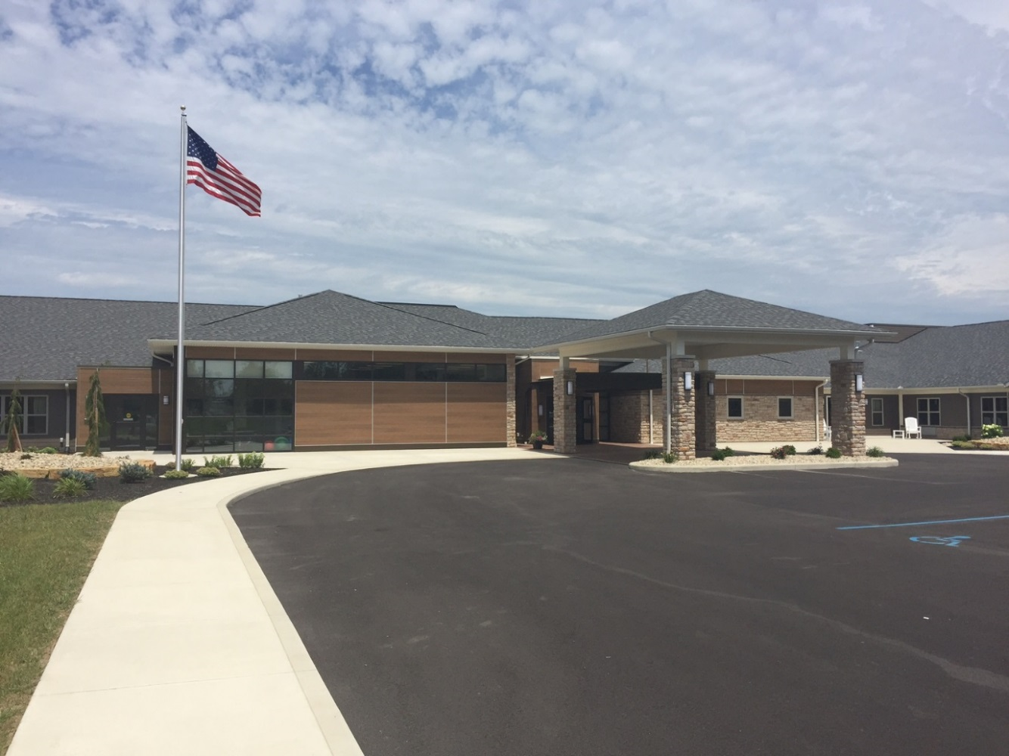

**Vancrest of Ada**

**January 2019**

**29th Edition**

Monthly News Letter

We are very excited to have finished another amazing year with our families here at Vancrest of Ada and are looking forward to all the good things to come in the 2019 year! A new baby with our Assisted Living Director and Assistant Administrator Sara Vordermark, welcoming Dustin Frey into the Director of Rehab position, and many fun and exciting events. We wanted to take a moment to Thank everyone in the community for supporting us throughout this last year and are looking forward to growing even more within the community in the coming year. We will also be missing Monty Siekerman as our liaison with the Ada Icon. We could always count on him to come and cover all of our events and get the perfect pictures. Happy Retirement Monty! We will be having our 3rd Annual Valentines Day Lunch on Thursday, February 14th at Noon. If you plan to attend with your loved one please call ahead and reserve your spot with Jennifer Line. We will have a menu for you to pick from as we will be doing our big meal again. This meal will $5 per person.

**“Tomorrow, is the first blank page of a 365-page book. Write a good one.” Brad Paisley**

**Focusing on What We Have Coming Up**

At Vancrest we are dedicated to keeping our residents happy, busy and excited about something we have planned. We strive to have a blissful religious service, delicious snack making, adventurous outings and the best entertainers possible. We have excellent volunteers and activity staff to help you with anything you wish to participate in. If you are looking for something to do with any spare time, we would love to have you come in and volunteer. Volunteering is as easy as talking with the residents, painting fingernails, playing games, or even coloring. Come in and See our Activities Director, Jennifer Line for details and a Volunteer application.

We hope that you find interest in some of our Life Enrichment Highlights this Month and come in to share in the fun:

* **January 8th 9:30 am Ada Library Drop**
* **January 8th 10:30 am Walking to Wellness Starts in Assisted Living**
* **January 15th 2:30 pm The Band Loco**
* **January 22nd 10:30 am Not an Ordinary Place in with AL**
* **January 23rd 1:30 pm Senior Citizens Group in to play games**
* **January 23rd, 6-8 pm Girl Scouts Visit**
* **January 31st 10:00 am Don Smithy to sing and play Saxophone**
* **Sunday Morning Church services at 10:00 am at Our Church-Rehab Dining Room**

**Employee Spotlight**

Amber Wolber Resident Assistant for our Assisted Living. Amber was one of the first employees hired here when the facility opened in 2016, at first working our 3rd shift position, but most recently changed to seconds. Amber has been a wonderful asset to our team and shows great care when it comes to her residents.

Amber celebrates her birthday on July 6th. She enjoys playing board games with her family on their spare time. They enjoy games such as Yahtzee and Rummikub. Her favorite food is comfort foods and she enjoys watching football. Her favorite teams are Ohio State and the Cleveland Browns. Amber loves the fall and sitting around the campfire in the cool weather it brings. Her favorite holiday falls in the summer though on July 4th. She enjoys family barbeques, watching fireworks, and just relaxing with family and friends. Amber has had some awesome vacations to talk about. She has been going on an annual camping trip in June with a group of friends for multiple years now and she has been on cruises to the Bahamas, Jamaica and the Cayman Islands.

Amber is married to her husband Joe for 9 years now. She also has 3 children daughter Ivy who attends OSU for nursing, daughter Kylen who is in 8th grade in Ada and son Kaine who is in 6th grade at Ada. Amber also attended Ada Schools and received her diploma from there before going on to The Ohio State University. She has a Bachelor Degree in Social and Behavioral Science. She worked for 10 years for Ada Visiting Nurses. Something she really enjoys now is seeing the smiles on the faces of her residents and listening to their stories about life.

Something we didn’t know about Amber was that she grew up on a Christmas Tree farm. The Bosse’s would choose and cut the Christmas Trees. She also enjoys watching comedies and horror movies. On Ambers Bucket list lies a couple of more trips. She would like to travel to Alaska and Ireland. What fun trips those would be!

If you have a chance this month be sure to stop down to our Assisted Living in the evening and you may just get the chance to talk with Amber.

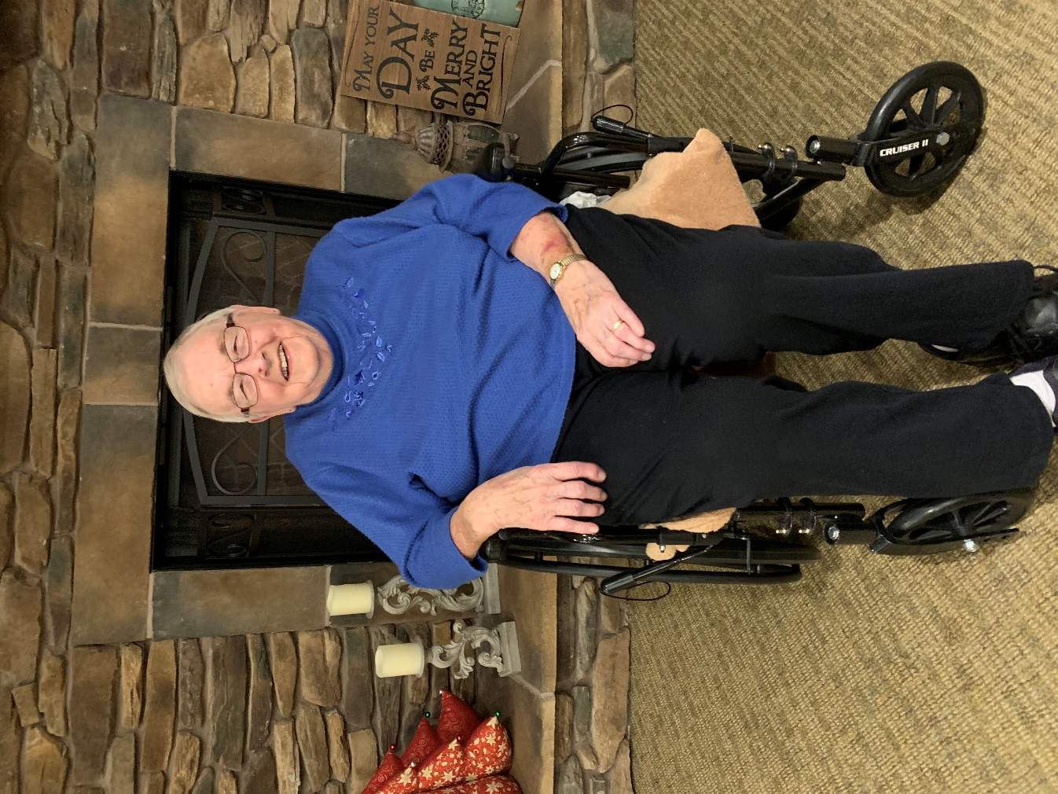**Resident Spotlight**

Betty Layman is a resident in our Assisted Living. She celebrates her birthday on April 24th. Betty is now a widow after being married to Allen for 60 years. They had 6 children together which include one adopted daughter and a set of twins. Betty enjoys reading in her free time and loves to pass the time doing it. She is not much into sports even though she is a pro at balloon volleyball. Betty’s favorite time of year is the fall with the changing leaves and the cooler weather. We just past her favorite holiday of Christmas. She loves to see her family get together and has many fond memories of Christmas’s from the past.

Betty’s favorite vacation was to Gatlinburg, Tennessee. She said this was one of the last vacations with her whole family before the kids started to move out. They really enjoyed the area and took a boat ride while there. Betty said she has done everything she ever wanted to do so she doesn’t really have a bucket list but if she had to have something on it she would travel to California. She has her husband’s sister there and their family and she would like to visit them and see them again.

Betty was born and raised in Michigan. She attended school at Summerfield Schools through graduation. It was located in Petersburg, Michigan. Betty worked at the Toledo Edison electric company in Michigan before coming to Ohio with her husband. He moved here with his job as a TV repairman. His company sent him here to help open the store in Lima. She got a job here at Chase Bank which used to be Bank One. The bank was where she said was her favorite job.

What she enjoys most about life now is seeing family. Being close with them has always been important to her. She used to have a garden at home raising mainly veggies but has some flowers too. She also enjoyed sewing and crocheting in her free time. She has made an Afghan for all of her grandchildren. Something else she loves to do is watch for the first Robin of Spring. She enjoys watching the birds outside her window but the Robin’s and Cardinals are her favorite.

I hope you get a chance to come down and visit with Betty this month as I am sure she would happy to see you.

**The Mission Statement of Vancrest of Ada is to Provide CARE:**

                      C             Customer Focused- Resident, Family &

Community

                                A Attitude- Always Display a Positive Attitude

                                R             Responsibility- Each Person Takes

Responsibility for Results

                                E            Empathy- Display Empathy to Customers in All

Situations

[](http://www.bing.com/images/search?q=clipart+nursing+home&id=621ABCC90AA72575AA3BFCB373D1031961E2D777&FORM=IQFRBA)

**We Will Achieve the Mission Through Key Objectives:**

1. Care- Individualized care that is delivered timely, proactively, professionally, and with a caring attitude.
2. Nutritional Services- The dining experience and meals will be served at the right

temperature, time, place, and nutritional value. We will offer a choice at each meal.

1. Facilities- Vancrest of Ada is an odor free, secure, accessible, and comfortable

facility.  This is accomplished by timely attention to investment in physical structure and pride in accommodations.

1. Activities- Meaningful and varied activities will be offered at a variety of times that will

stimulate the senses and be fun.

1. Staff- Employees at Vancrest of Ada strive for total customer satisfaction in everything

we do by accomplishing results in a proactive, professional approach.

|  |  |
| --- | --- |
| January |  |
|  | 2019 |
| Long-Term Care Life Enrichment Calendar | Activities are subject to change. Changes will be made to the large wall calendar outside of the Dining Room. |

|  |  |  |  |  |  |  |
| --- | --- | --- | --- | --- | --- | --- |
| Sunday | Monday | Tuesday | Wednesday | Thursday | Friday | Saturday |
|  |  | Happy New Years! 1 | 2 | 3 | 4 | 5 |
|  |  | 10:00 am Church  2:00 pm Reminiscing | 10:00 am Pictionary  2:00 pm Exercise  3:00 pm Coloring Pages | 10:00 am Bullseye  1:30 pm Therapy Dog Visit  2:00 pm Bible Study | 10:00 am Cornhole  10:30 am John Reading  2:00 pm Bingo  3:00 pm Ice Cream | 10:00 am Reminiscing  2:00 pm Bingo  3:30 pm Activity Pages |
| 6 | 7 | 9:30 am Library Drop off 8 | Word Nerd Day 9 | 10 | National Milk Day 11 | 12 |
| 10:00 am Our Church-Communion  11:30 am Reminiscing | 10:00 am Exercise  2:00 pm Bingo  3:00 pm Nail Spa | 10:00 am Pictionary  2:00 pm Craft  7:00 pm Church | 10:00 am Hang Man game  2:00 pm Cookie with a Cop  3:00 pm Crossword/Word Search Puzzles | 10:00 am Exercise  1:30 pm Therapy Dog Visit  2:00 pm Bible Study | 10:00 am Bullseye  10:30 am John Reading  2:00 pm Bingo  3:00 pm Ice Cream | 10:00 am Reminiscing  2:00 pm Bingo  3:30 pm Activity Pages |
| 13 | 14 | National Bagel Day 15 | 16 | 17 | 18 | 19 |
| 10:00 am Our Church  11:30 am Reminiscing | 10:00 am Balloon Games  2:00 pm Bingo  3:00 pm Nail Spa | 10:00 am Exercise  2:30 pm The Band Loco  3:30 pm Reminiscing  7:00 pm Church | 10:00 am Ring Toss  2:00 pm Exercise  3:00 pm Coloring Pages | 10:00 am Bullseye  1:30 pm Therapy Dog Visit  2:00 pm Bible Study | 10:00 am Crazy Legs  10:30 am John Reading  2:00 pm Bingo  3:00 pm Ice Cream | 10:00 am Reminiscing  2:00 pm Bingo  3:30 pm Activity Pages |
| National Cheese Lovers Day 20 | National Heroes Day 21 | Long-Term Care Omelets 22 | Assisted Living Omelets 23 | National Peanut Butter Day 24 | Opposite Day 25 | 26 |
| 10:00 am Our Church  11:30 am Reminiscing | Rehab Omelets Day  10:00 am Corn Hole  2:00 pm Bingo  3:00 pm Nail Spa | 10:00 am Ring Toss  2:00 pm Balloon Games  7:00 pm Church | 10:00 am Facts and Trivia  2:00 pm Exercise  3:00 pm Snack Surprise | Pediatrist is here  10:00 am Activity Pages  1:30 pm Therapy Dog Visit  2:00 pm Bible Study | Dentist is here  10:00 am Reminiscing  10:30 am John Reading  2:00 pm Bingo  3:00 pm Ice Cream | 10:00 am Reminiscing  2:00 pm Bingo  3:30 pm Activity Pages |
| 27 | National Fun at Work Day 28 | 29 | 30 | 31 |  |  |
| 10:00 am Our Church  11:30 am Reminiscing | 10:00 am Balloon Games  2:00 pm Bingo  3:00 pm Nail Spa | 10:00 am Exercise  2:00 pm Resident Council  3:00 pm Birthday Party  7:00 pm Church | 10:00 am Ring Toss  2:00 pm Corn Hole  3:00 pm Reminiscing | 10:00 am Don Smithy Singer and Saxophone  1:30 pm Therapy Dog Visit  2:00 pm Bible study |  |  |
|  |  |  |  |  |  |  |
|  |  |  |  |  |  |  |

|  |  |
| --- | --- |
| January |  |
|  | 2019 |
| Assisted Living Life Enrichment Calendar | Activities are subject to change. Changes will be made to the large wall calendar outside of the Dining Room. |

|  |  |  |  |  |  |  |
| --- | --- | --- | --- | --- | --- | --- |
| Sunday | Monday | Tuesday | Wednesday | Thursday | Friday | Saturday |
|  |  | Happy New Years! 1 | 2 | 3 | 4 | 5 |
|  |  | 10:00 am Church  2:00 pm Reminiscing | 10:30 am Pictionary  2:30 pm Exercise  3:30 pm Find a Word  6:00 pm Game Night | 10:30 am Bullseye  2:00 pm Bible Study  3:30 pm Balloon Games | 10:30 am Cornhole  1:45 pm Bingo  2:45 pm Ice Cream | 10:00 am Reminiscing  2:00 pm Bingo  3:30 pm Activity Pages |
| 6 | 7 | 9:30 am Library Drop off 8 | Word Nerd Day 9 | 10 | National Milk Day 11 | 12 |
| 10:00 am Our Church-Communion  11:30 am Reminiscing | 10:30 am Exercise  1:45 pm Bingo  2:45 pm Nail Spa | 10:30 am Walking to Wellness kick off  3:00 pm Craft  7:00 pm Church | 10:30 am Hang Man game  2:00 pm Cookie with a Cop  3:30 pm Crossword/Word Search Puzzles  6:00 pm Game Night | 10:30 am Exercise  2:00 pm Bible Study  3:30 pm Wheel of Fortune | 10:30 am Bullseye  1:45 pm Bingo  2:45 pm Ice Cream | 10:00 am Reminiscing  2:00 pm Bingo  3:30 pm Activity Pages |
| 13 | 14 | National Bagel Day 15 | 16 | 17 | 18 | 19 |
| 10:00 am Our Church  11:30 am Reminiscing | 10:30 am Balloon Games  1:45 pm Bingo  2:45 pm Nail Spa | 10:30 am Walking to Wellness  2:30 pm The Band Loco  3:30 pm Reminiscing  7:00 pm Church | 10:30 am Ring Toss  2:30 pm Exercise  3:30 pm Find a Word  6:00 pm Game Night | 10:30 am Bullseye  2:00 pm Bible Study  3:30 pm Exercise | 10:30 am Crazy Legs  1:45 pm Bingo  2:45 pm Ice Cream | 10:00 am Reminiscing  2:00 pm Bingo  3:30 pm Activity Pages |
| National Cheese Lovers Day 20 | National Heroes Day 21 | Long-Term Care Omelets 22 | Assisted Living Omelets 23 | National Peanut Butter Day 24 | Opposite Day 25 | 26 |
| 10:00 am Our Church  11:30 am Reminiscing | Rehab Omelets Day  10:30 am Corn Hole  1:45 pm Bingo  2:45 pm Nail Spa | 10:30 am Not an Ordinary Place-games/craft  2:30 pm Balloon Games  7:00 pm Church | 10:30 am Facts and Trivia  1:45 pm Senior Citizens Group of Ada to come to play Games  6-8pm Girl Scouts-craft/game  6:00 pm Game Night | Pediatrist is here  10:30 am Activity Pages  2:00 pm Bible Study  3:30 pm Corn Hole | Dentist is here  10:30 am Reminiscing  1:45 pm Bingo  2:45 pm Ice Cream | 10:00 am Reminiscing  2:00 pm Bingo  3:30 pm Activity Pages |
| 27 | National Fun at Work Day 28 | 29 | 30 | 31 |  |  |
| 10:00 am Our Church  11:30 am Reminiscing | 10:30 am Balloon Games  1:45 pm Bingo  2:45 pm Nail Spa | 10:30 am Walking to Wellness  2:00 pm Resident Council  3:30 pm Birthday Party  7:00 pm Church | 10:30 am Ring Toss  2:00 pm Slushies for Safety  3:30 pm Reminiscing  6:00 pm Game Night | 10:00 am Don Smithy Singer and Saxophone  2:00 pm Bible study |  |  |
|  |  |  |  |  |  |  |
|  |  |  |  |  |  |  |

****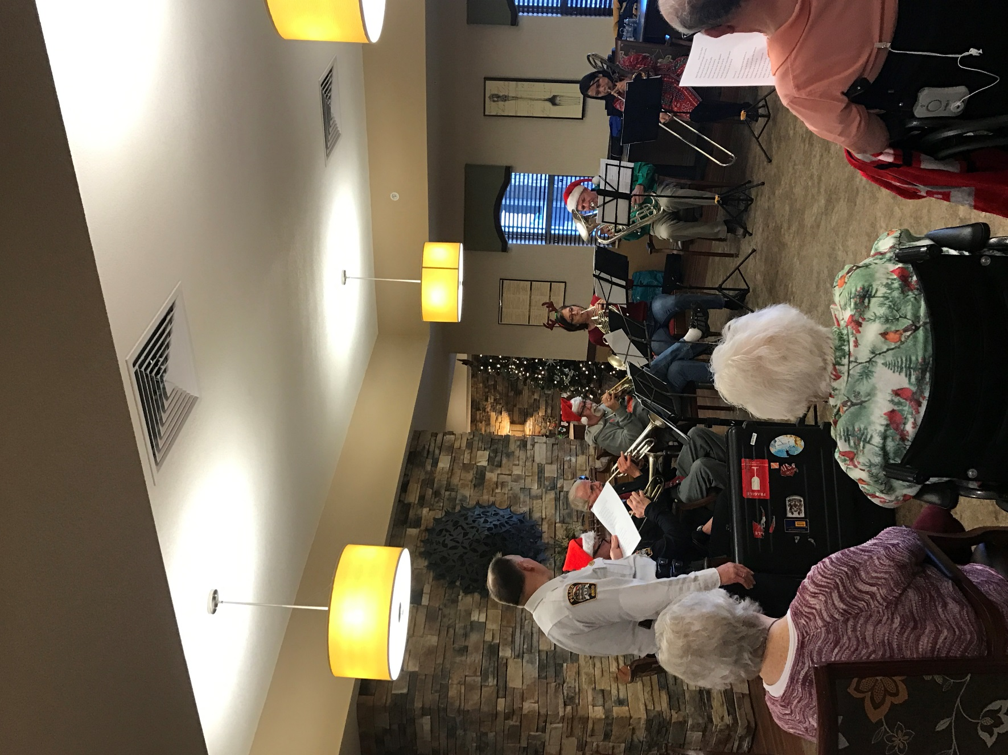

Carols with a Cop

**Keep an eye out for yours!**

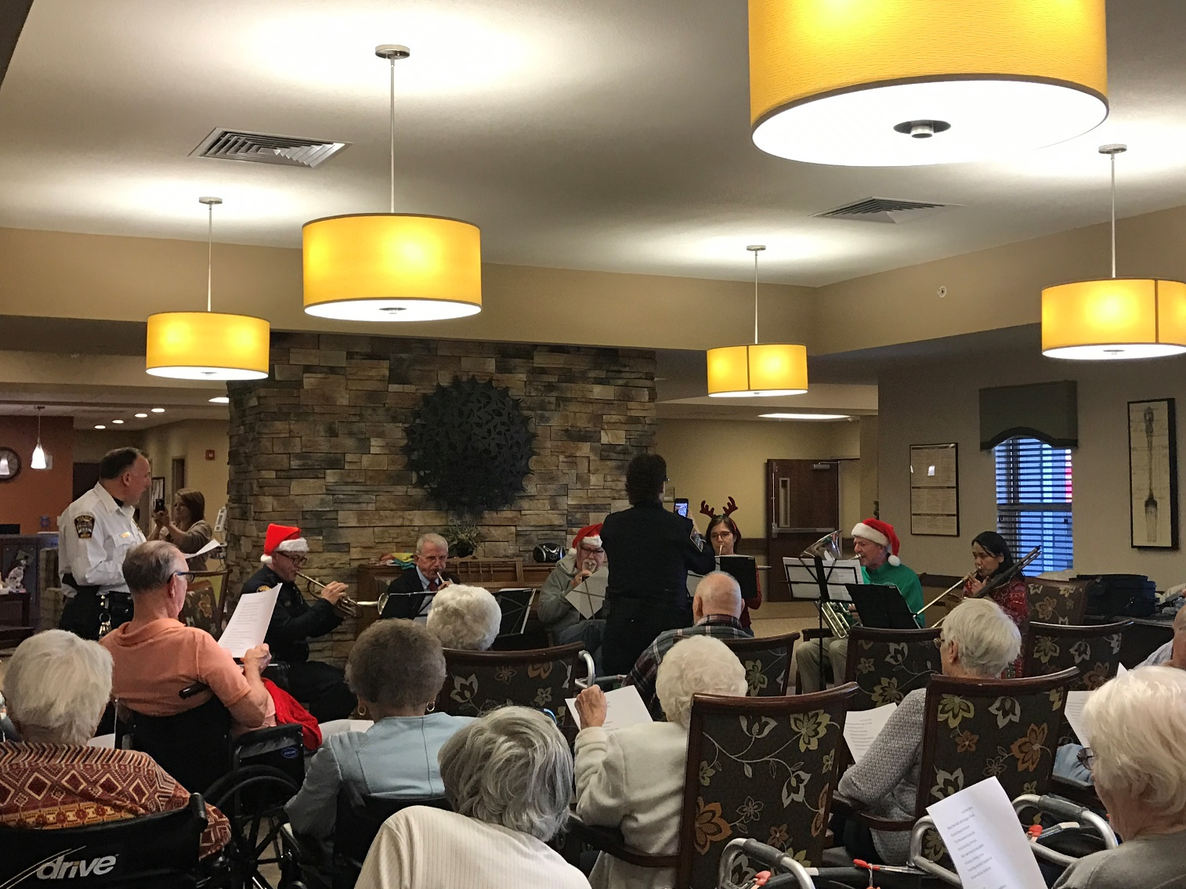

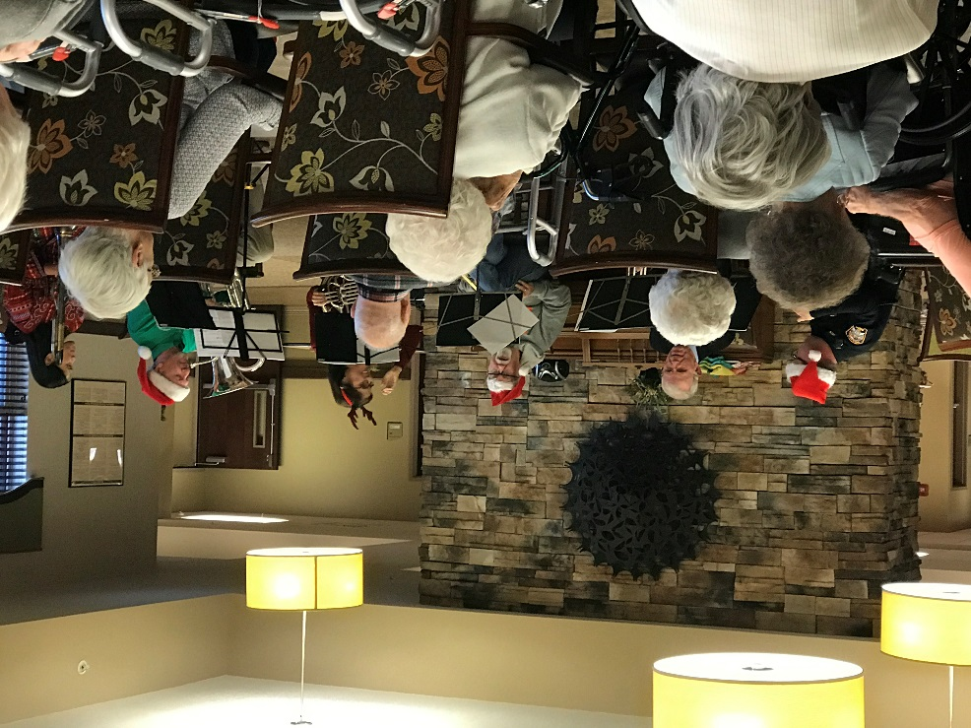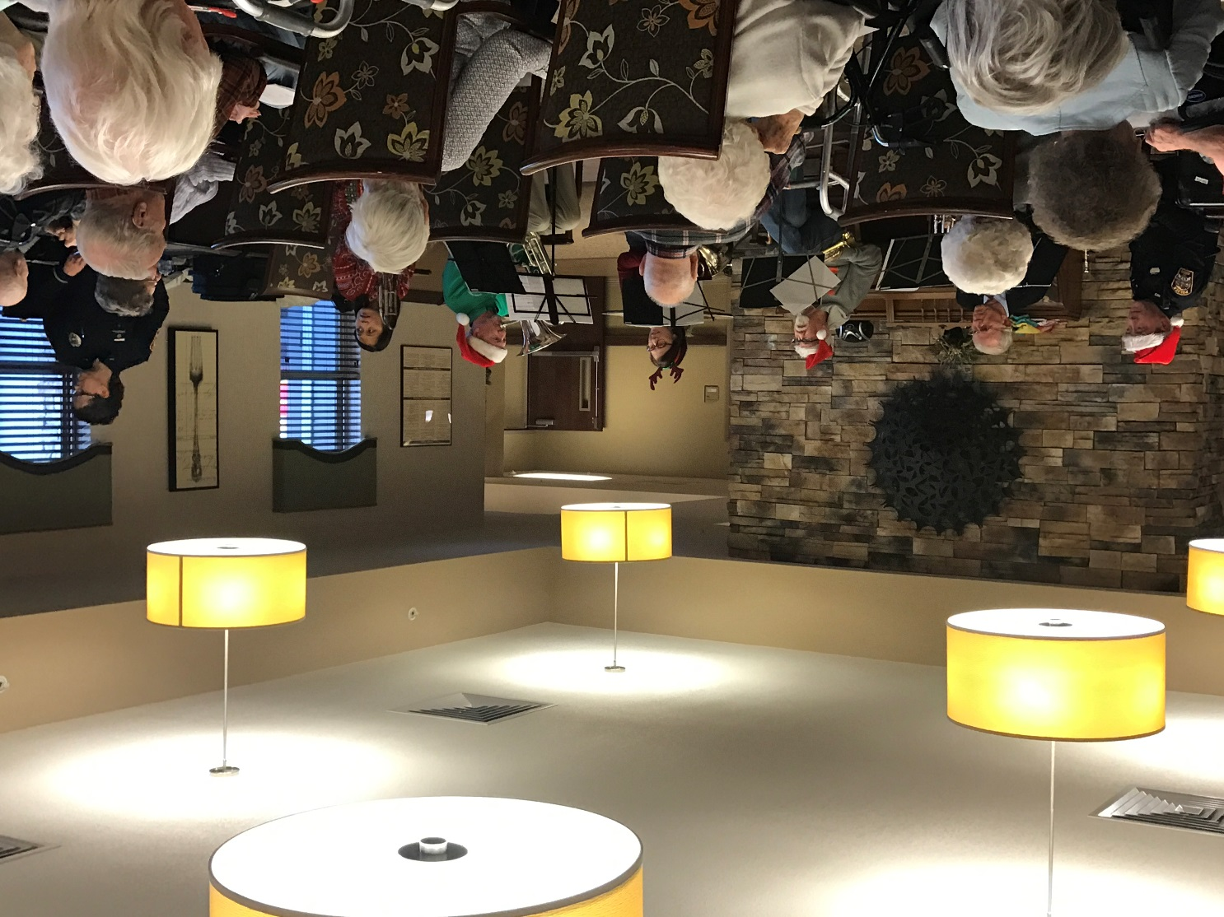

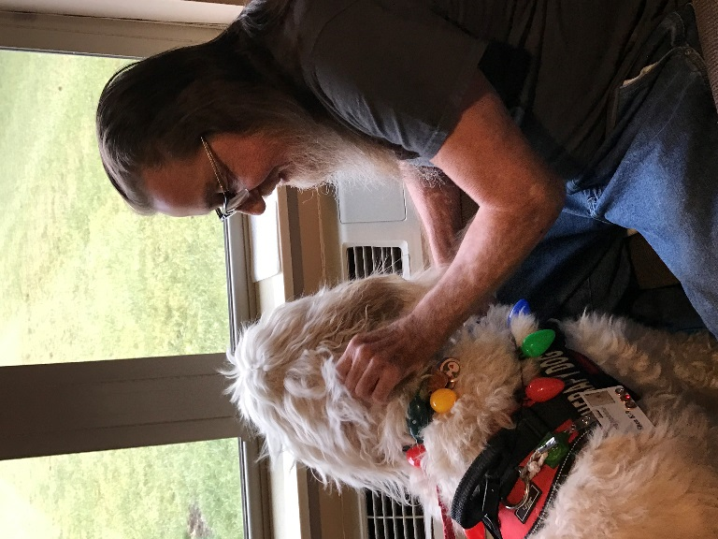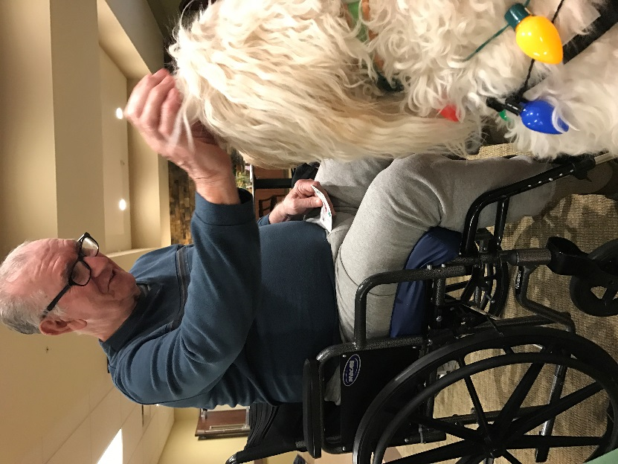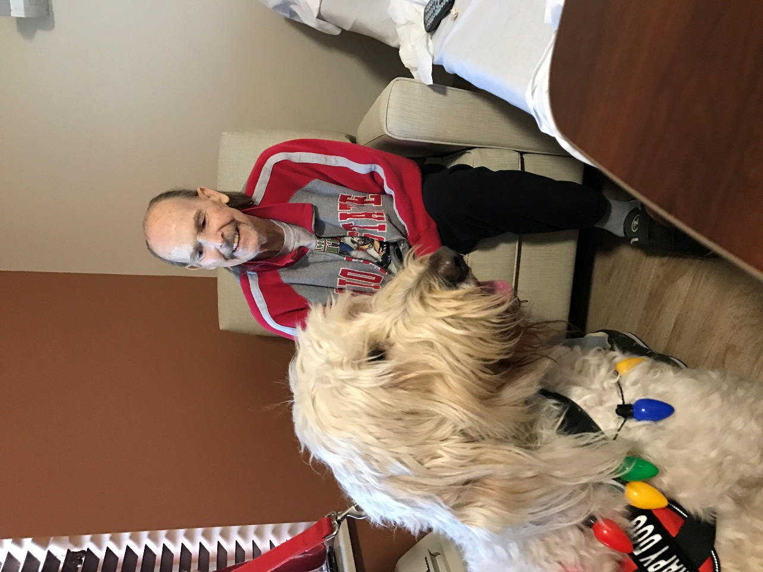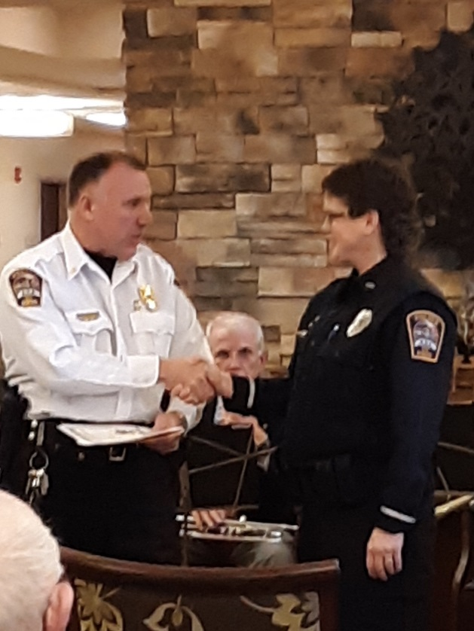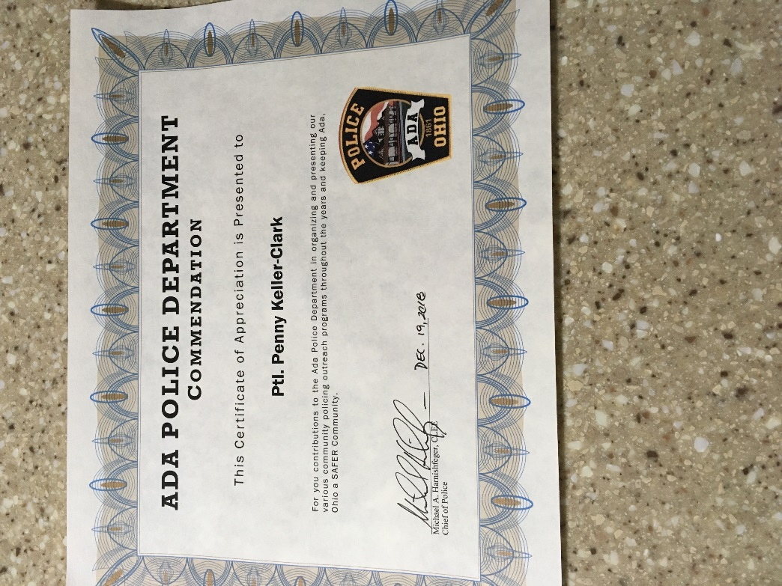

**Therapy Dog Shea**

Police Commendation Award

**Attention: Email Addresses Wanted**

**Please contact our Social Worker, Kayla Herrmann with a regularly checked contact email. You can do so by email her at** [**kherrmann@vancrest.com**](mailto:kherrmann@vancrest.com) **or calling Monday thru Friday 8am-4:30pm at 419-558-1379.**