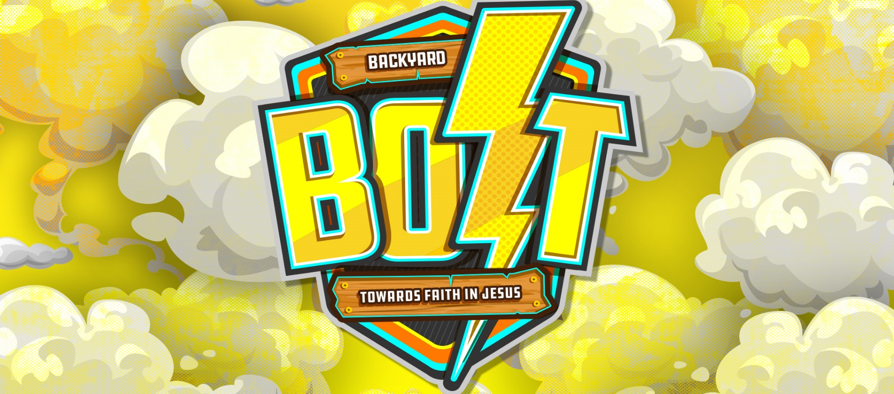

Hi Ada families and distant friends!

We are so excited to announce that VBS WILL BE HAPPENING this year! With one modification, though. Instead of you bringing your kids to VBS, we’re bringing VBS to your kids.

This summer, on June 22, 24, and 26, we’ll be using a quarantine-friendly VBS called BOLT. With minimal preparation, easy-to-follow instructions, and a video that leads you and your kids step-by-step through each of the 3 days, BOLT is designed for you to perform with your family at home. It’s so simple!

During BOLT, your family will participate in fun games that illustrate what it means to listen to, focus on, and follow Jesus. Depending on your pace, you can expect that each day’s experience will last about an hour and a half. It’s great for kids 4 and up. Even middle and high school kids can enjoy it!

There’s something else we’re really excited about—this could also be an amazing outreach opportunity. If you feel comfortable gathering with more people, you can invite as many neighbors, friends, and family to your house for BOLT as you would like. It’s such an easy and fun way to share the good news of Jesus with our community.

Please register with the google form on the Ada FUMC website, adaumc.org.

We’ll be sending you more information regarding supply pickup and zoom invitations after registration. In the meantime, get your family excited about BOLT. This is going to be SO MUCH FUN!

In Him,

Caitlin Porter and Anna Yoakam

When: June 17th – Registration deadline at adaumc.org
June 21st – pick-up supplies at Ada FUMC Church (301 North Main Street)
June 22nd, 24th, 26th – VBS video dates with Zoom Share from 7:00-7:30

Where: In your own home!

How: Game and craft supplies will be provided for pick up. Internet is required for ZOOM participation, but
options are available for no internet homes. Please let us
know if internet is not available in your home!

If you have a smart phone, here is the QR code for the registration:

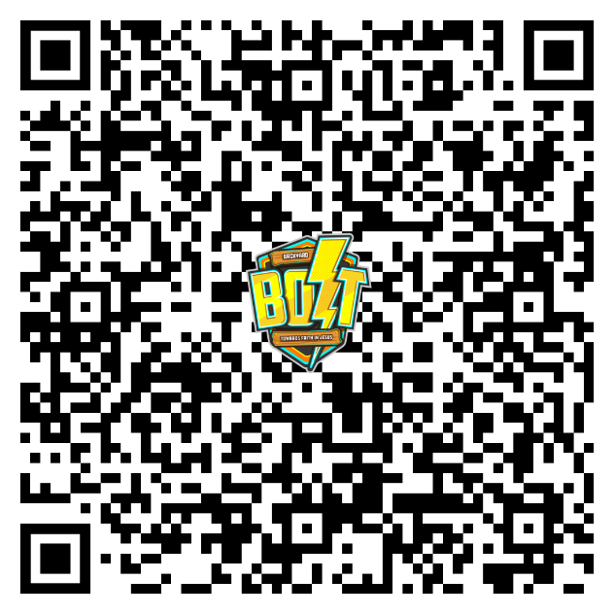

Contact details:
Caitlin Porter: teach2enable@gmail.com
Anna Yoakam: Anna.Yoakam@adaumc.org

