210 N. Main St., P.O.B. 232
Ada OH 45810
P: 419-558-1015 | F: 419-558-1105 restorecenter@gmail.com

More news and online giving on ReStore’s Facebook page: facebook.com/restore.communitycenter.7

October — November 2016 Newsletter

ReStore’s 10th Anniversary Celebration: November 1, 2016

November 1 will be a special crockpot, celebrating ReStore’s 10th anniversary.


Join us to honor this amazing community institution.

ReStore founding member Karen Ward will speak about the centre, as will ReStore regulars. We will have a blessing and a birthday cake.

Below, we have reflections from Robert Kanzig, ReStore’s current interim director, and founder Karen Ward.
Robert Kanzig: This place has given community to those who need it since day one. At the beginning, we had seniors hanging out every day. With our lunches, we brought in a lot of people. Crockpot Tuesday is a huge community event. And for Thanksgiving, up to 250 people every year celebrate with us. In a town of 2500, that’s impressive.

The founders had a really great vision. Even though change has occurred, I’d like to think we’re still honoring their vision. Being here for 10 years shows the strength of the vision and the necessity of it.

Karen Ward: Psalm 51 tells us: ‘ReStore to me the joy of your salvation and grant me a willing spirit to sustain me.’
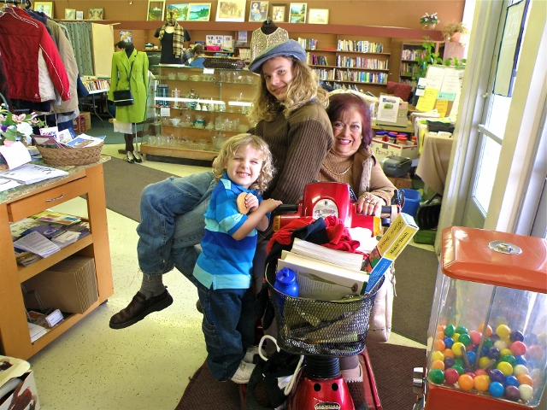

We began ReStore as a group of church members – people believing in the reality of Jesus Christ as the Savior of all people sent to earth by God.

But it is hard to enter a church building for some – it can feel like entering a private club.

We felt that we needed a neutral place, no membership required, if we really wanted to be in service. A place to put the coffee on, provide a few racks of clean and good clothes for anyone who wanted them, and have a pot of soup on Tuesday nights.

Most important was to bring our heart and soul to this place. It didn’t seem to matter if the floor was uneven or the furniture didn’t match or the clothes weren’t the right size. What happened was genuine hospitality, openness, and love were in the room. (continued from page 1)
Beloved volunteer Sharon Binkley; Isaac Zika, who took a leave from his college education to serve with ReStore for a year; and Alexander King, a young customer who liked the cookies and fun to be had in the Center. (Photo by Karen Ward)

That was the crux of living Christ to all the community.

But of course, in living this principle of love, most of us found it for ourselves too. It became a sacred way of thinking to realize that any moment, as a person enters, it could be Jesus walking in the door. It was never just a one-way act of love, warmth and hospitality – it was twofold and redeeming to all our hearts.

When we began ReStore, the community response was amazing. People just started coming in. We had people scraping paint, cleaning. It was such a beautiful reaction.

Over the years, so much has happened at ReStore. We have amazing volunteers and donations. We’ve had a wedding there and a baptism. ReStore is now open five days a week, from two afternoons initially, and we serve lunch.

No one will starve in this community as long as ReStore is there. Even more, being open means that there is a place to have fellowship, to be warm, to be recognized, to get together with other humans.

Picnic in the Park Draws Record Numbers of Ada Kids

For the fifth year, ReStore sponsored Picnic in the Park this summer. Picnic in the Park provides lunch and activities for local children at Ada's War Memorial Park, every weekday from June through August. Calvin Fisher manages Picnic in the Park, with help from ReStore volunteers, including Eva Wilkie and Dawn Bischoff.
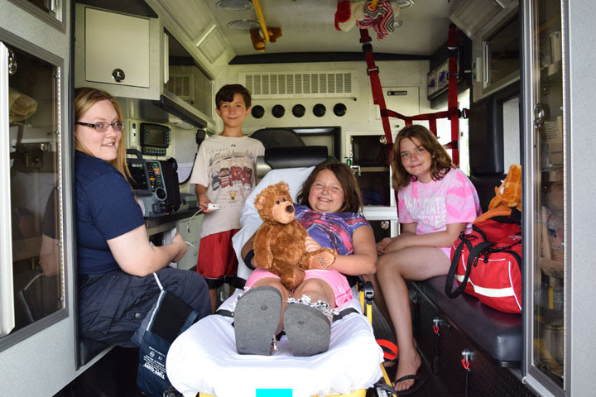

This year, record numbers of kids participated. Calvin’s commitment is key to the program’s success. “I’ve got 13 grandchildren of my own,” Calvin explains. “I’m always around kids. I love kids – anybody’s kids – and I treat them all the same.”

This year, kids participated in a host of fun and educational activities. On Fridays, they had had pizza from Padrone’s and played on a splash pad. They were able to choose gifts, provided by Calvin and generous donors. The police and fire departments visited regularly, letting the kids explore their vehicles. Kids learned about fingerprinting, crime scene investigation, and the role of the police.
Emergency responders let Ada kids explore an ambulance at Picnic in the Park over the Fourth of July weekend. (Photo by Ada Icon.)

For the kids, those bonds with police officers can be valuable, said Calvin. “When the police first came out, the kids were all paranoid,” Calvin recalls. “I said, ‘No, those are the people you want to talk to if something’s wrong.’”

Special thanks to Padrone’s for donating the much appreciated Friday pizzas.

Volunteer: Marco’s Closet, Crockpot, and Thanksgiving

ReStore needs you! We have many volunteer opportunities. Volunteers can help sort donated goods for Marco’s Closet. They can sponsor Crockpots. And, they can help with ReStore’s annual Thanksgiving feast. Please call ReStore or stop by to find out more.

We also thank our current donors: most recently, Quest Bank, Ferguson Insurance, and Grimslid & Hood for supporting our Harvest and Herb Festival root beer floats.

Stop by! ReStore’s hours are: Mon 11-4 PM | Tues 11-6 PM (community dinner 4-6 PM) | Wed – Fri 11-4 PM

