_________________________________________________________________________________________________________
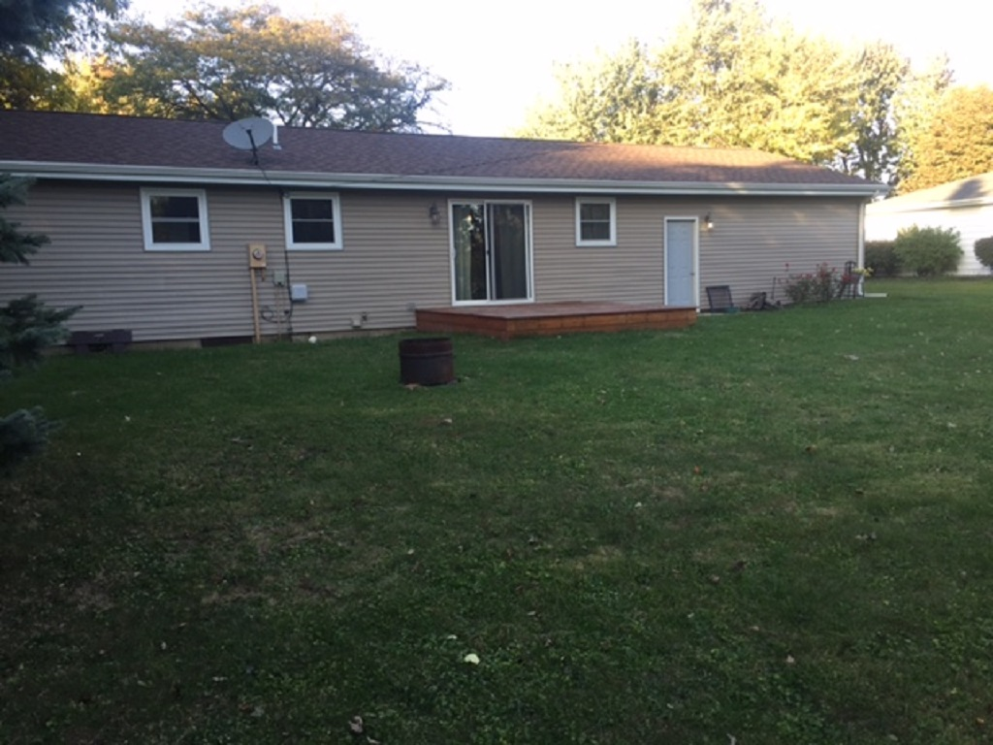
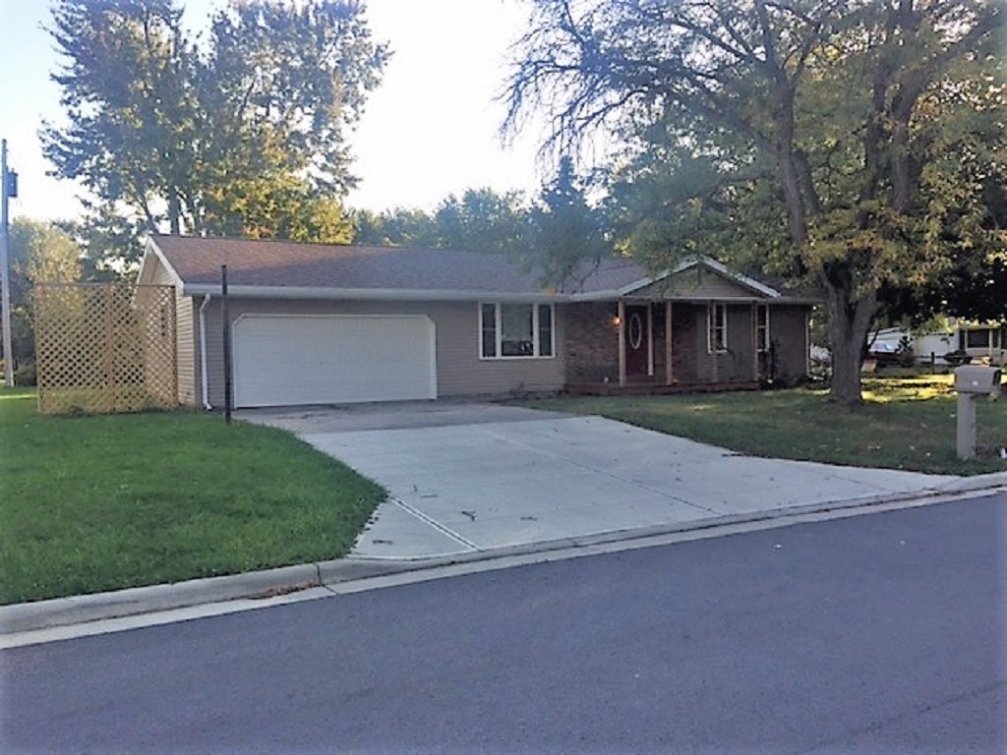

Century 21

Sunway Realty LLC

930 E. Columbus St.
Kenton, Ohio 43326
Phone: 419-675-2333
Fax: 419-675-2899

Ad Code: KP-301
MLS #
LISTER:
Doug Carmean
567-674-8688

ADDRESS: 301 E. Valerie Ave. Ada 7-RMS 3-BDRMS 1- BA PRICE: $110,000
_________________________________________________________________________________________________________

TYPE: 1 Story/Ranch ELEC. SERVICE: All electric
CONST: Stick/Vinyl HEAT: Baseboard Heat
LOT SIZE: 84 x 107 AIR COND.: No central air
TAXES: $1168.00 WATER: City
AGE: 1970 SEWER: City
SCHOOL: Ada Schools ROOF: Shingle-5 yrs
ZONING: Residential DRIVE: Concrete
1 ST FLOOR 2ND FLOOR FLOORING
POSSESION: Immediate

KITCHEN: 20’x13’ Wood LIV. SQ. FT.: 1100 sq ft

DINING: BASEMENT: Crawl

LIVING: 20’x12’ Carpet GARAGE: 2 car attached

BATH: 5’x8’ Vinyl WINDOWS: Vinyl 2 yrs. old

BATH: INSULATION: New 2 yrs. old

(M)BEDRM: 12’x10’ Carpet KIT. CABINETS: New 2 yrs. old

BEDRM: 12’x9’ Carpet DISHWASHER: New 2 yrs. old

BEDRM: 10’x9’ Carpet DISPOSAL: No
UTILITY: 8’x5’ Vinyl BUILT-INS: Refrig,stove,dishwasher
OFFICE:

Enchanting Residence Stylish flair! Check the virtues of this elegant residence. Delightfully different home that's a haven of serenity. Circle this 3-bedroom residence with heavenly comforts. Interesting style and flair! A charming ambiance enhances this engaging residence. Provides lovely living. Informally stylish home. Extraordinary residence with gorgeous appointments. Warmth and charm pervade this very fine treasure of a home. Do come see all that it offers

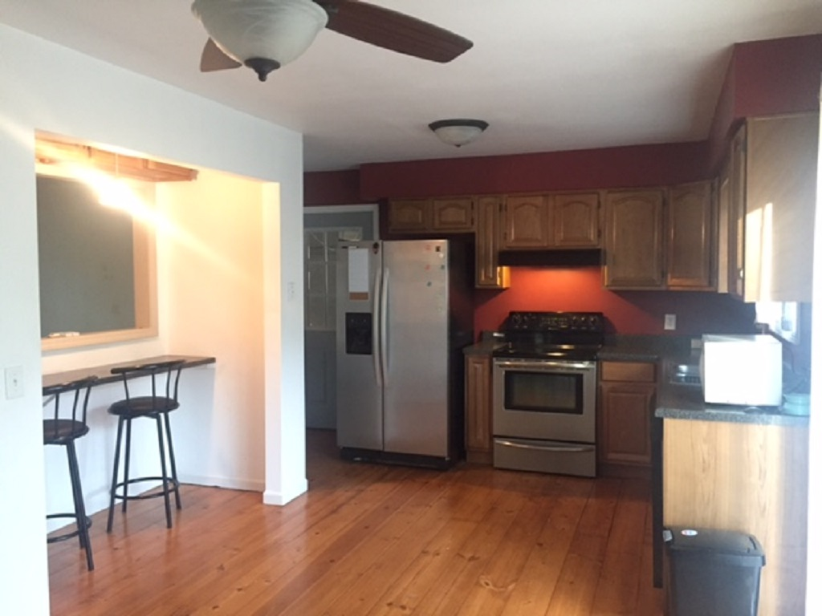
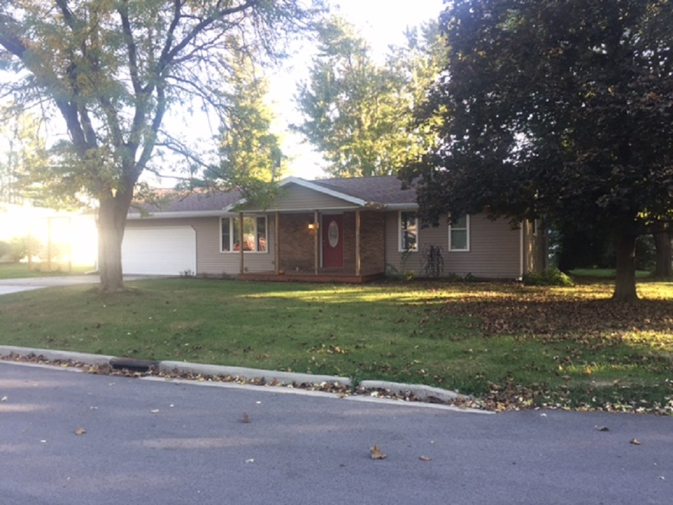
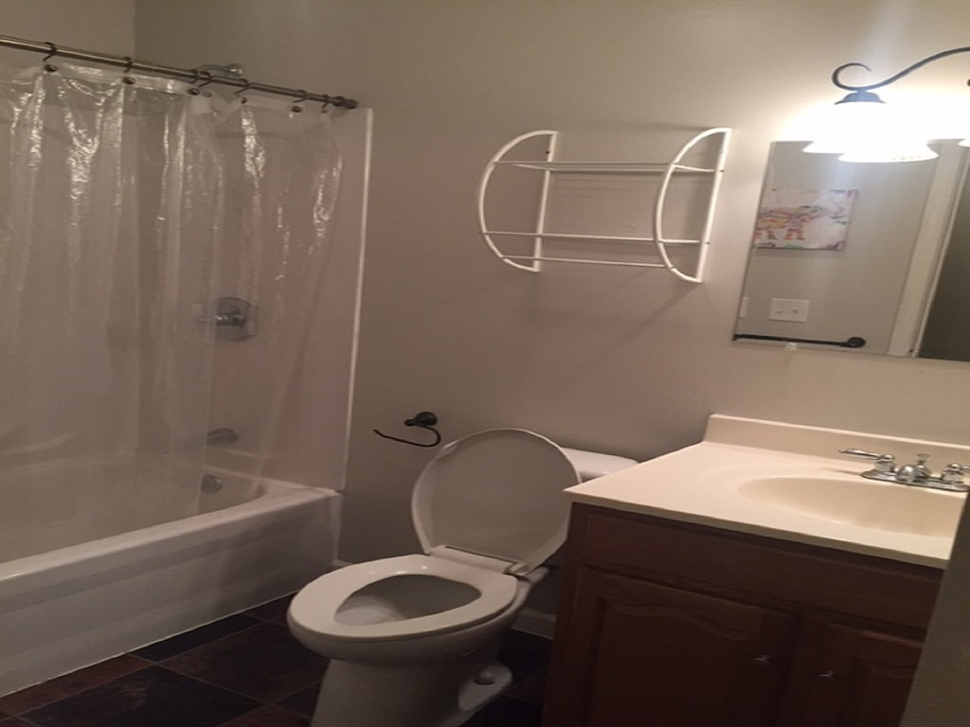
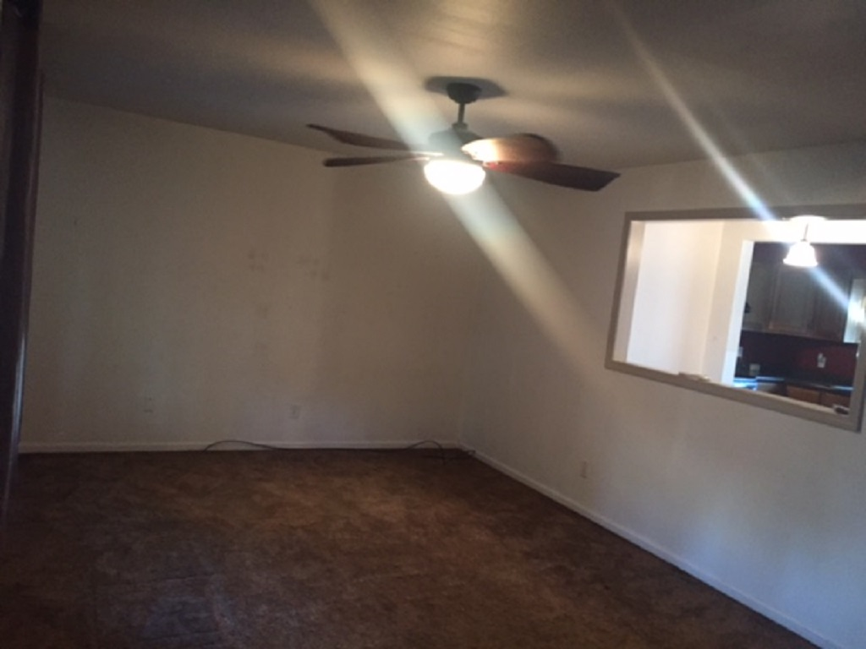

THIS INFORMATION THOUGH BELIEVED ACCURATE IS NOT GUARANTEED

