BOARD OF EDUCATION

Dr. Amy Mullins, President
Mr. Matt Gossman, Vice President
Mr. Ronald Fleming
Ms. Nancy Wood Allison
Mr. Ernest Daugherty
Mrs. Kim Light, Treasurer
Mrs. Meri C. Skilliter, Superintendent of Schools

CLASS MOTTO
“Life isn’t about waiting for the storm to pass.
It’s learning to dance in the rain.” Vivan Greene

CLASS COLORS CLASS FLOWER
Purple and Gold Rose

CLASS OFFICERS

President: Acel Gamble

Vice President: Olivia Alexander

Secretary: Melina Woods
Treasurer: Caitlyn Stover

CLASS ADVISOR

Mrs. Melody Veltri

HIGH SCHOOL FACULTY

Mrs. Robin VanBuskirk, K-12 Principal
Mr. Daniel Lee, Assistant Principal
Mr. Benjamin Thaxton, Assistant Principal

David Ames Sean Anderson Christina Bowden Tracy Breidenbach Shawn Christopher Tyler Craig Sarah Davis Tony Dyer William Faine Suzanne Hardesty Scott Henning Sheila Hughes
Jeffrey Hunt Ken Jochims Joshua Klein Kurt Klingler Jonathan Lischak David Lusk Robert Olwin Eric Perkins Erinn Prater Kristin Salyer Karen Schaffner Jeffrey Schleeter Alayne Schrock Chanda Smith Kristie Steiner Mike Styer Rachel Temple Julie Thaxton Melody Veltri Elizabeth Vogt Gary Wells Anna Yoakam

One Hundred Thirty-Fifth Annual

ADA HIGH SCHOOL

COMMENCEMENT

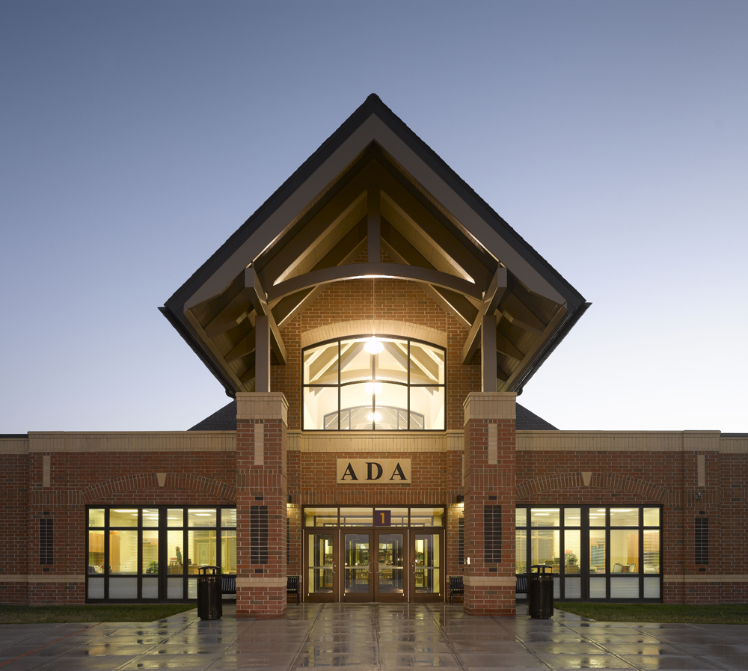
Class of 2018

Ada High School Gymnasium
Sunday, May 27, 2018
2:00 p.m.

CLASS OF 2018
Victor Thomas Lama
Jacob Daniel Lee^
Kelsey Jordan Lee
Nicole Renee Lehsten◊>*
Justin David Light
Lexus Shaleigh Lunguy◊>*
Kara Ann Manning
Kaitlyn Marie Newland◊>*
Sydney Jane Newland>*
Alivia Diane Okuly
Noah James Christopher Pinkney◊>*
Madison Lynn Preston
Johnathan Woodrow Rettig◊>*
Cole Alan Robinson^
Colten Lee Shafer
Terrence Errol Sheridan III◊>
Caleb Matthew Stobbe
Caitlyn Alexandra Stover◊>*
Jayson Chase Sumner◊>*
Alexis Faith Swaney>*
Ethan Michael Swaney
Gizem Tanriverdi◊>
Sydney Lauren VanAtta>
Alexandra Ann Waugh◊>*
Mason Maclain Waugh
Shaqueal Rashaude White^
Xander Cedrick White
Logan Cole Williams◊>
Seven Noah Williams
Zachary Allen Wilson^
Melina Jane Woods◊>*
Catherine Colleen Young>*

Olivia Keiffer Alexander◊>*
Nathan David Allen
Anney Madison Archer
Adam Michael Bailey
Zachary David Beaschler◊>*
Lacey Abbigail Boutwell^
Zachary Dan Breidenbach
Brayan Ulises Casiano
Dalton Joseph Cochrane^
Kiser Zackary Colley◊>*
Seth Allen Conley◊>*
Jackson Wayne Conrad◊>*
Marin Elaine Cook*
Kade Logan Cortez
Teara Marie Coulson
Lindsay Nicole Crouse
Blaine Allen Dearth
Hunter Michael England
Aaron Matthew Everhart>*
Calvin Chadwick Fields
Ivy Lynn Fisher◊>*
Acel Douglas Scott Gamble
Madisyn Ann Gossard◊>*
Kylie Marie Guagenti◊>*
Shelby Nicole Higgins
Taylor Lynn Hoffer^
Jakob William Hoschak
Alexander Michael Hurtig◊>*
Justice David Jenkins
Lyric Lynn Eloise Jones◊>*
Erryk Stephan Katayama◊>*
Caleb Levi Klausing
Zoë Alexis Klingler◊>*
Jackson Robert Lee Kloeppel^

◊ Honors Diploma > 3.5 GPA or higher
* National Honor Society ^ Apollo Career Center

COMMENCEMENT

* “Fanfare and Processional” Elgar Ada High School Band
* “Star Spangled Banner” Francis Scott Key Dr. Jonathan M. Lischak, Director

MOMENT OF REFLECTION Johnathan Rettig, Class of 2018

WELCOME Mrs. Robin VanBuskirk, Ada K-12 Principal

HIGHLIGHTS OF THE CLASS OF 2018 Mr. Dan Lee, Ada Assistant Principal

GREETINGS FROM APOLLO CAREER CENTER Mr. Nick Sammetinger, Apollo

“The Mii Channel Theme” Senior Ada High School Band Members
arranged by Jacob Colwell – Ada High School Dr. Jonathan M. Lischak, Director

“You Will Be Found” from Dear Evan Hansen Ada High School Choir
by Pasek and Paul Mr. Scott Henning, Director

ANNOUNCEMENT OF SALUTATORIAN AND VALEDICTORIANS Mrs. Meri C. Skilliter, Ada Superintendent

SALUTATORIAN Terrence Errol Sheridan III

VALEDICTORIANS Olivia Keiffer Alexander
Kiser Zackary Colley
Alexander Michael Hurtig
Lyric Lynn Eloise Jones
Erryk Stephan Katayama
Noah James Christopher Pinkney
Melina Jane Woods

INTRODUCTION OF SPEAKER Mrs. Meri C. Skilliter, Ada Superintendent

COMMENCEMENT ADDRESS Mr. Dave Lusk, Ada HS Chemistry/Physics Teacher

CERTIFICATION OF GRADUATES Mrs. Robin VanBuskirk, Ada K-12 Principal

RECOGNITION OF GRADUATES Dr. Amy Mullins, Pres. Ada Board of Education

PRESENTATION OF THE CLASS Mrs. Melody Veltri, Ada Senior Class Advisor

* “Fanfare and Recessional” Ada High School Band
Dr. Jonathan M. Lischak, Director
*Audience please stand as able

