BOARD OF EDUCATION

Dr. Amy Mullins, President
Mr. Matt Gossman, Vice President
Mr. Ronald Fleming
Mr. Ernest Daugherty
Mr. Troy Erickson
Mrs. Kim Light, Treasurer
Mrs. Meri C. Skilliter, Superintendent of Schools

CLASS MOTTO
It is impossible to live without failing at something, unless you live
so cautiously that you might as well not have lived at all---
in which case, you fail by default. -J.K. Rowling

CLASS COLORS CLASS FLOWER
Purple and Gold Juliet Rose

CLASS OFFICERS

President: Noah Mattson

Vice President: Brendan Sheridan

Secretary: Raina England
Treasurer: Jacob Colwell

CLASS ADVISOR

Mrs. Melody Veltri

HIGH SCHOOL FACULTY

Mrs. Robin VanBuskirk, Director of Teaching & Learning
Mr. Dan Lee, Middle School/High School Principal
Mr. Benjamin Thaxton, Elementary Principal

David Ames Sean Anderson Morgan Bass
Christina Bowden Tracy Breidenbach Shawn Christopher Tyler Craig Sarah Davis Tony Dyer William Faine Joan Faisant Suzanne Hardesty Scott Henning Sheila Hughes Jeffrey Hunt Ken Jochims Joshua Klein Kurt Klingler Jill Laughlin Jonathan Lischak David Lusk Eric Perkins Erinn Prater Kristin Salyer Alayne Schrock Chanda Smith Kristie Steiner Mike Styer Rachel Temple Trent Temple Julie Thaxton Melody Veltri Elizabeth Vogt Gary Wells Anna Yoakam

One Hundred Thirty-Sixth Annual

ADA HIGH SCHOOL

COMMENCEMENT

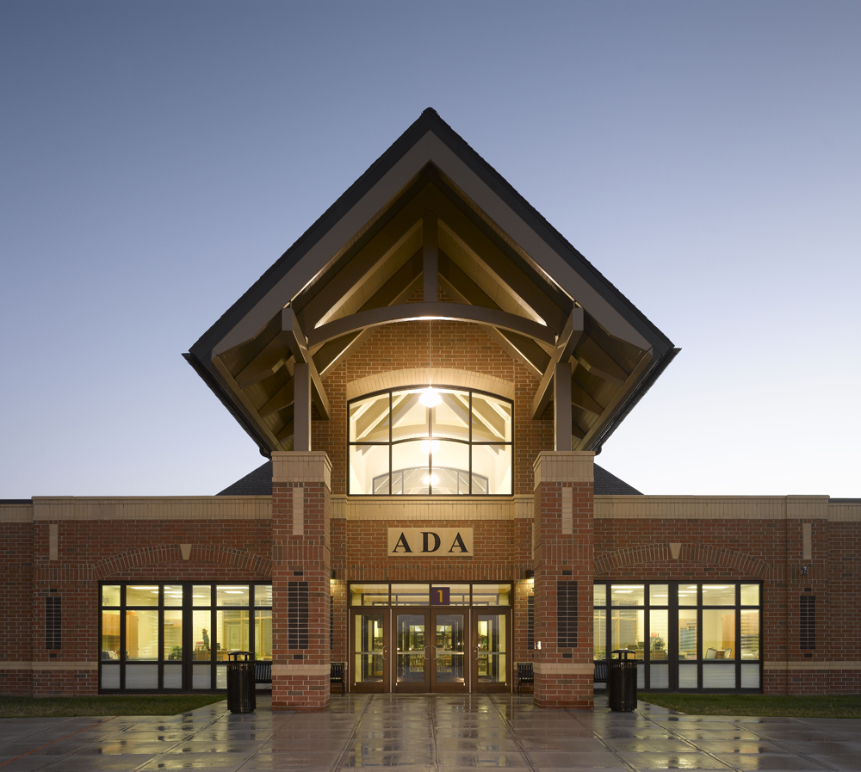
Class of 2019

Ada High School Gymnasium
Sunday, May 26, 2019
2:00 p.m.

Emma Elizabeth Jameson◊>*
William Heath Jolliff, Jr.>
Caitlin Rose Kilgallon
Alexander Nabil Lama
Loniesha Unique Lee
Rebecca Elizabeth MacDonald
Nathan Paul Mattson>*
Noah Paul Mattson>*
Nathaniel Allen McClure-Nira
Amyah Elizabeth Mullett
Cade Joseph Mullins◊>*
Jacob Dean Okuly◊>*
Joseph Tyler Onions
Christopher Reyes
Abbygal Nicole Rostorfer Chamberlain
Brooklyn Marie Rudasill
Cheynne Vanessa Rudasill
Serena Blain Salyers^
Kelsi Leeanne Sarnescky
Brendan Michael Sheridan◊>
Abigail Ri’anne Spangler^
Kolton David Spangler
Johnathon Dean Spradlin^
Shelby Nicole Sprague^
Morgan Elizabeth Swick◊>*
Sumaya Tasnim◊>*
Bryce Edward Tidd
Keli Li Trudeau◊>*
Zachary Black Vassil-Horse
Lilia Ann Walker
Rylee Hope Webb
Destayne Loree White^
James Anthony Wilson>*

Anabel Grace Alexander◊>*
Robert Scott Allison
Austin Michael Amburgey◊>*
Kama Leigh Arn◊>*
Jaylin Lee Burkhart
Hailey Sue Callahan >*
Charles Brayden Lee Cheney
Bradley Allen Clum II
Jacob Green Colwell◊>*
Taylor Erin Combs^
Rilan Danielle Conley
Baylei Elizabeth Cooper
Shelby Rae Davie^
Allison Dean Dotson◊>
Zohie Lysette Dysert>
Levi Wiatt England^
Raina Devon England◊>*
Alexis Noel Ennis*
Olivia Nicole Ennis*
Abigail Lynne Erickson
Landon Kyle Evans^
Brice Alexander Ferguson◊>*
Emma Ree-Ann Ferguson
Connor Michael Frazier
Damien Lynn Eldon Fuqua
Noah Campbell Garmon
Curtis Lloyd Geckle
Miguel Luis-Everardo
Gonzalez-Jordan◊>*
Shelby Marie Goodman
Ethan James Hall
Jibriel N Hasan
Audrey Alexis Hazelton◊>*
Samuel David Hibbard
Olivia Alexandra Hiester^
Carson Robert Hissong◊>
Courtney Marie Hollar^
Xavier Esteban Hollinger

◊ Honors Diploma > 3.5 GPA or higher
* National Honor Society ^ Apollo Career Center

COMMENCEMENT

* “Fanfare and Processional” Elgar High School Band
* “Star Spangled Banner” Francis Scott Key Dr. Jonathan M. Lischak, Director

MOMENT OF REFLECTION Noah Mattson, President, Class of 2019

WELCOME Mr. Dan Lee, Middle School/High School Principal

HIGHLIGHTS OF THE CLASS OF 2019 Mrs. Robin VanBuskirk,
Director of Teaching & Learning

GREETINGS FROM APOLLO CAREER CENTER Ms. Tasha Sheipling

“Symphonic Suite from Pirates of the Caribbean” by Klaus Badelt High School Band Members
Dr. Jonathan M. Lischak, Director

“I’m Gonna Sing til the Spirit Moves in My Heart” by Moses Hogan
“The Road Home” by Stephen Paulus High School Choir
Mr. Scott Henning, Director

ANNOUNCEMENT OF SALUTATORIAN AND VALEDICTORIANS Mrs. Meri C. Skilliter, Superintendent

SALUTATORIAN Miguel Gonzalez-Jordan
VALEDICTORIANS Austin Amburgey
Jacob Colwell
Brice Ferguson
Cade Mullins

INTRODUCTION OF SPEAKER Mrs. Meri C. Skilliter, Superintendent

COMMENCEMENT ADDRESS Mr. Dave Lusk, Chemistry/Physics Teacher

CERTIFICATION OF GRADUATES Mr. Dan Lee,
Middle School/High School Principal

RECOGNITION OF GRADUATES Dr. Amy Mullins, President, Board of Education

PRESENTATION OF THE CLASS Mrs. Melody Veltri, Senior Class Advisor

* “Fanfare and Recessional” High School Band
Dr. Jonathan M. Lischak, Director
*Audience please stand as able

