**Current Updates:**

* We are still not accepting visitors at this time.

* We are accepting items for our residents Monday-Friday now from 8am -4 pm.  **Please be sure these items have residents FIRST and LAST name on them so they make it to the right person.**

* Facetime calls and scheduling will be handled by Jennifer Line and Rena Lawrence effective immediately in preparation for Kayla’s maternity leave.

* Aaron Maidlow will be filling in many of Kayla’s other jobs so please reach out to him during this time with any questions that are normally directed to Kayla.

* We are still accepting pictures for Channel 3 to play for our residents on the picture loop. Please send them to [jline@vancrest.com](mailto:jline@vancrest.com) .

* We will be doing another Drive through parade on Wednesday, July 8th 2020 at 4:30 pm. Line up in Ada Schools front parking lot at 4:00 pm. Rain date will be Thursday, July 9th 2020.

**\*\* Our Church would like to encourage resident families to join in our Sunday services. \*\***

**\*\*As of July 1st, 2019, we will no longer be accepting any new refrigerators in the Long-Term Care Rooms. \*\***

** When coming in to eat with your family members please let the kitchen know as soon as possible so we make sure to have a plate ready for you. **

**\*\* Refrigerator in Rehab Dining Room continues to be a problem with items that have no name or date labels on them. These items must be labeled with resident name and the date they are put in, they will be discarded 3 days later. If an item is found that doesn’t have a label it will be immediately discarded. If this continues to be an issue we may have to eliminate the use of this fridge for residents as this is a state violation.**

**\*\*A quick reminder when you come to visit please take a peek in your loved one’s closet. If you see it is overstuffed and there may be things they don’t wear, take them home with you. Also, be mindful of the weather changes. When you start bringing in the heavier clothes for the wintertime, please take home the summer clothes.**

**\*\*If you wish to receive your copy of The Ada Articles through email, please email** [**jline@vancrest.com**](mailto:jline@vancrest.com) **and we will get you on the list for the electronic version. Thank You!\*\***

**\*\* Council on Aging is always available as an option for transportation for medical appointments to our Assisted Living. See Sara Vordermark for additional info.**

**Contact us**

If you have any questions or would like to discuss any of the services we offer, please contact us!

600 W. North Ave.

Ada, Ohio 45810

[](http://webserver.vancrest.com/)Phone: (419)558-1379

Fax: (419)558-1385

Web: www.Vancrest.com



600 W. North Ave

Ada, Ohio 45810

**The Ada Articles**

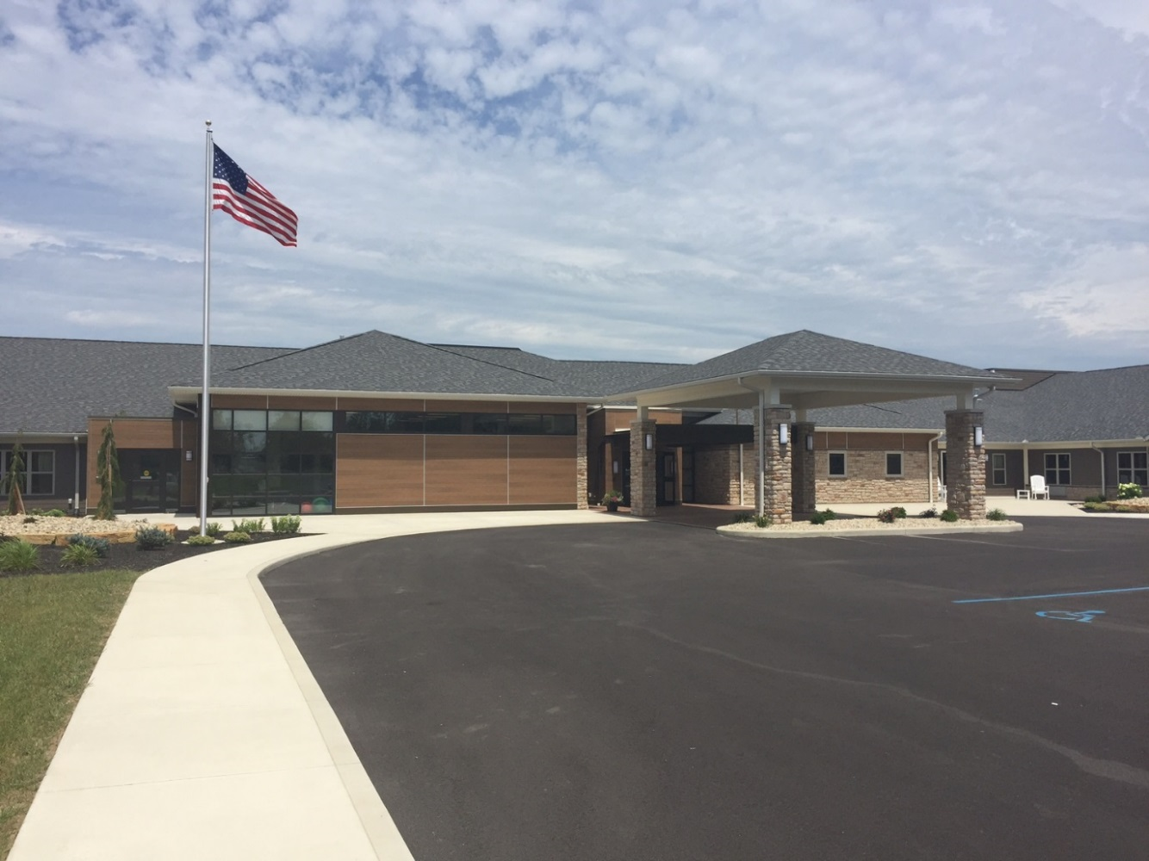

**Vancrest of Ada**

**June 2020**

**46th Edition**

Monthly Newsletter

Hello everyone! I can’t believe we are starting June already! We are just as anxious to bring visitors back in as soon as we get the word from the state. We are grateful for your ongoing patience and continued support during this time. There are still many questions and we hope to give you answers for everything you need. We are asking that you give us just a little more time before bringing in all the summer clothes for your loved ones. With the air conditioning on in the building everyone is staying comfortable and we aren’t making as many trips outside as we would under normal circumstances. We are still accepting items for your loved ones in the front lobby just please be sure they are labeled with their names. Also, remember these items will go through a sanitation process of 24 hours before they are given to the resident. (If they are brought on Friday those items won’t go out until Monday.) We hope to see everyone soon!

**Difficult roads often lead to beautiful destinations. The best is yet to come-Zig Ziglar**

**Focusing on What We Have Coming Up**

At Vancrest we are dedicated to keeping our residents happy, busy and excited about activities we have planned. We strive to have a blissful religious service, delicious snack making, adventurous outings and the best entertainers possible. We have excellent volunteers and activity staff to help with anything our residents wish to participate in. If you are looking for something to do with any spare time, we would love to have you come in and volunteer. Volunteering is as easy as talking with the residents, painting fingernails, playing games, or even coloring. Come in and see our Activities Director, Jennifer Line for details and a volunteer application.

We hope that you find interest in some of our Life Enrichment Highlights this Month and come in to share in the fun:

* **2:00 pm Thursday Bible Study**
* **June 18-25th pm Nurse Aide Week**
* **June 25th 3:00 pm LTC and 3:30 pm AL Monthly Birthday Party**
* **Sunday Morning Church services at 10:00 am at Our Church Channel 3**

**\* When calling to schedule your facetime calls please ask to speak to Jennifer Line or Rena Lawrence as Kayla will be leaving for materinty leave.**

**Employee Spotlight**

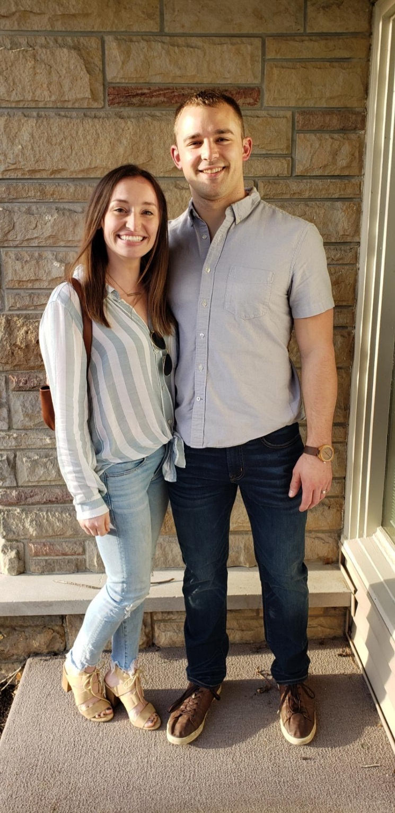

Emma Pohlman is our Speech Language Pathologist. She attended Delphos St. John’s where she graduated High School. She then went on to receive her undergraduate degree from the University of Cincinnati and her Master’s degree in Speech Language Pathology from East Tennessee State University in 2017. She has enjoyed working in many different settings like schools, acute care, outpatient and long-term care facilities. She said that this is her favorite occupation because of all the different ways she can help someone. She enjoys things like helping someone communicate with their family, helping them eat their favorite foods safely, and helping them learn the skills to make them more independent. Emma’s favorite part of her job is seeing the residents achieve their goals.

Emma is married to her husband Joel who she met in high school. They have no children at this time but plan to start a family in the future. She does currently have a dog named Rain. She enjoys eating seafood. Her favorite season is Fall with the changing leaves, cooler weather and soccer season. She enjoys watching and coaching high school soccer in her free time. Emma played soccer in High School and intramural in college.

Emma said her favorite vacation was to Rome, Italy. Emma and her husband took her grandma after she retired. It was on her grandma’s bucket list to see the Vatican and they wanted to help her check that off. Emma’s bucket list includes a trip to New Zealand. She has family there and would love to visit them. She also would like to see the beautiful mountains and beaches New Zealand has to offer.

Emma’s favorite holiday is Christmas. She loves spending time with her family and seeing everyone during that time of year. Something about Emma that many of us didn’t know is that she was born in Scotland. She moved to America with her family when she was 3 years old. Emma has such a sweet personality and always wears a smile to share with others.

**Resident Spotlight**

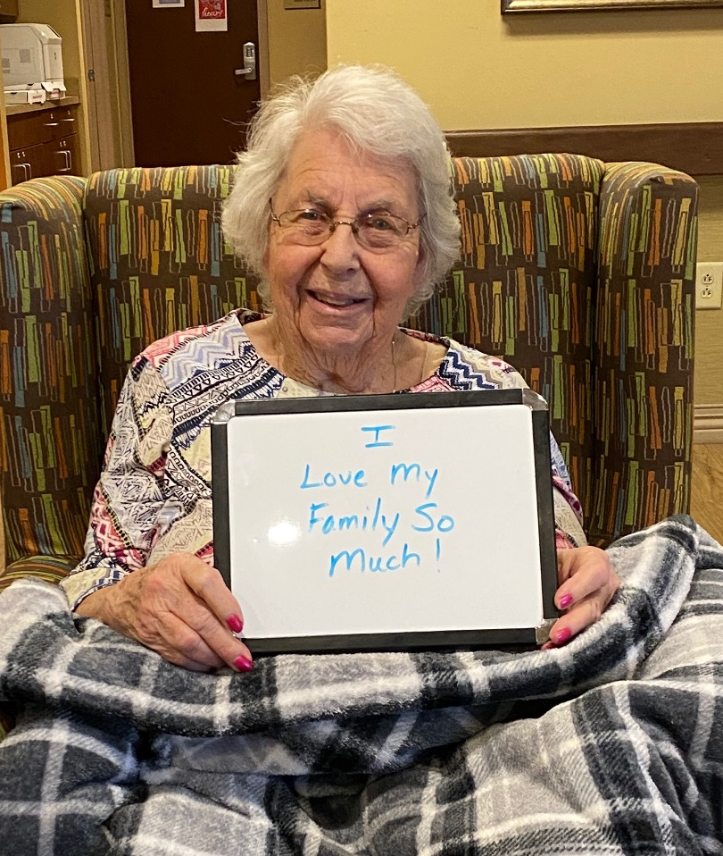

Anna Mae Spallinger was born in Haskins, Ohio later moving to Lafayette. She attended school there and graduated from Lafayette Jackson where she met her husband Don. Anna Mae and Don were married for 63 years and had 4 children together, Pat, Pam, Scott and Amy. Don worked at Ford and on the family farm and Anna Mae worked at the Wishing Well at ONU. She worked there over seeing special events for 10-15 years and really enjoyed it. She also helped on the farm and with the animals until Scott was old enough to help take over with them. Anna Mae and the girls also took care of the yard taking turns mowing and keeping things looking great.

After Don retired they spent from November until March or April in Florida. They loved going to the clubhouse and playing cards or shuffleboard. Anna Mae also attended exercise classes in the morning with another group of ladies and often stayed for the dance class that followed. This doesn’t come as much of a surprise as she loves to dance! She also had a group of ladies that she would get together with and play cards once a week. They enjoyed the game hands and feet.

Anna Mae enjoys ice cream and spaghetti and most seasons as long as it isn’t winter. She always enjoyed attending High School football games and being with her family. Anna Mae’s favorite holidays are Christmas and Easter because she always loved hosting those with her family. You will see Anna Mae at her best when she is with her family, you simply can’t beat the love in her eyes and the smile she has the moment she sees them.

An interesting story about Anna Mae is that when she was younger and living in Lafayette her grandmother came to visit and when she left to go home Anna Mae got to take the train with her to Tontogany, Ohio which is by Bowling Green. I hope you have a chance to see Anna Mae and if music is on have a dance with her.

**The Mission Statement of Vancrest of Ada is to Provide CARE:**

                      C             Customer Focused- Resident, Family &

Community

                                A Attitude- Always Display a Positive Attitude

                                R             Responsibility- Each Person Takes

Responsibility for Results

                                E            Empathy- Display Empathy to Customers in All

Situations

[](http://www.bing.com/images/search?q=clipart+nursing+home&id=621ABCC90AA72575AA3BFCB373D1031961E2D777&FORM=IQFRBA)

**We Will Achieve the Mission Through Key Objectives:**

1. Care- Individualized care that is delivered timely, proactively, professionally, and with a caring attitude.
2. Nutritional Services- The dining experience and meals will be served at the right

temperature, time, place, and nutritional value. We will offer a choice at each meal.

1. Facilities- Vancrest of Ada is an odor-free, secure, accessible, and comfortable

facility.  This is accomplished by timely attention to investment in physical structure and pride in accommodations.

1. Activities- Meaningful and varied activities will be offered at a variety of times that will

stimulate the senses and be fun.

1. Staff- Employees at Vancrest of Ada strive for total customer satisfaction in everything

we do by accomplishing results in a proactive, professional approach.

|  |  |  |  |  |  |  |
| --- | --- | --- | --- | --- | --- | --- |
|  |  |  |  |  |  |  |

|  |  |
| --- | --- |
| June |  |
|  | 2020 |
| Long Term Care Life Enrichment Calendar | Activities are subject to change. Changes will be made to the large wall calendar outside the dining room. |

|  |  |  |  |  |  |  |
| --- | --- | --- | --- | --- | --- | --- |
| Sunday | Monday | Tuesday | Wednesday | Thursday | Friday | Saturday |
|  | 1 | 2 | 3 | 4 | 5 | 6 |
|  | 10:00 am Manicures in the living room  2:00 pm Room visit nails | 10:00 am Trivia Tuesday  2:00 pm Balloon Games  3:00 pm Room Visits | 10:00 am Corn Hole  2:00 pm Music Man Channel 3  3:00 pm Balloon Games | 10:00 am Craft  2:00 pm Bible Study  3:00 pm Snack Surprise | 10:00 am Exercise  2:00 pm Bingo | 10:00 am Reminiscing  2:00 pm Balloon Games |
| 7 | 8 | 9 | 10 | 11 | 12 | 13 |
| 10:00 am Our Church  Channel 3  2:00 pm Reminiscing | 10:00 am Manicures in the living room  2:00 pm Room visit nails | 10:00 am Trivia Tuesday  2:00 pm Balloon Games  3:00 pm Room Visits | 10:00 am Exercise  2:00 pm Music Man Channel 3  3:00 pm Balloon Games | 10:00 am Craft  2:00 pm Bible Study  3:00 pm Snack Surprise | 10:00 am Exercise  2:00 pm Bingo | 10:00 am Reminiscing  2:00 pm Balloon Games |
| 14 | 15 | 16 | 17 | STNA Week 18 | STNA Week 18 | 20 |
| 10:00 am Our Church  Channel 3  2:00 pm Reminiscing | 10:00 am Manicures in the living room  2:00 pm Room visit nails | 10:00 am Trivia Tuesday  2:00 pm Balloon Games  3:00 pm Room Visits | 10:00 am Bullseye  2:00 pm Music Man Channel 3  3:00 pm Balloon Games | 10:00 am Craft  2:00 pm Bible Study  3:00 pm Snack Surprise | 10:00 am Exercise  2:00 pm Bingo | 10:00 am Reminiscing  2:00 pm Balloon Games |
| 21 | STNA Week 22 | STNA Week 23 | STNA Week 24 | STNA Week 25 | 26 | 27 |
| 10:00 am Our Church  Channel 3  2:00 pm Reminiscing | 10:00 am Manicures in the living room  2:00 pm Room visit nails | 10:00 am Trivia Tuesday  2:00 pm Balloon Games  3:00 pm Room Visits | 10:00 am Exercise  2:00 pm Music Man Channel 3  3:00 pm Balloon Games | 10:00 am Craft  2:00 pm Bible Study  3:00 pm Birthday Party | 10:00 am Exercise  2:00 pm Bingo | 10:00 am Reminiscing  2:00 pm Balloon Games |
| 28 | 29 | 30 |  |  |  |  |
| 10:00 am Our Church  Channel 3  2:00 pm Reminiscing | 10:00 am Manicures in the living room  2:00 pm Room visit nails | 10:00 am Trivia Tuesday  2:00 pm Balloon Games  3:00 pm Room Visits |  |  |  |  |
|  |  |  |  |  |  |  |

|  |  |
| --- | --- |
| June |  |
|  | 2020 |
| Assisted Living Life Enrichment Calendar | Activities are subject to change. Changes will be made to the calendar outside the Activity Office. |

|  |  |  |  |  |  |  |
| --- | --- | --- | --- | --- | --- | --- |
| Sunday | Monday | Tuesday | Wednesday | Thursday | Friday | Saturday |
|  | 1 | 2 | 3 | 4 | 5 | 6 |
|  | 10:30 am Manicures in the living room  2:30 pm Room visit nails | 10:30 am Trivia Tuesday  2:30 pm Balloon Games | 10:30 am Corn Hole  2:00 pm Music Man Channel 3  3:30 pm Balloon Games | 10:30 am Craft  2:30 pm Bible Study  3:30 pm Snack Surprise | 10:30 am Exercise  2:00 pm Bingo 700 hall and right side of 600  2:45 pm Bingo 500 hall and left side of 600 hall | 10:00 am Reminiscing  2:00 pm Balloon Games |
| 7 | 8 | 9 | 10 | 11 | 12 | 13 |
| 10:00 am Our Church  Channel 3  2:00 pm Reminiscing | 10:30 am Manicures in the living room  2:30 pm Room visit nails | 10:30 am Trivia Tuesday  2:30 pm Balloon Games | 10:30 am Exercise  2:00 pm Music Man Channel 3  3:30 pm Balloon Games | 10:30 am Craft  2:30 pm Bible Study  3:30 pm Snack Surprise | 10:30 am Exercise  2:00 pm Bingo 700 hall and right side of 600  2:45 pm Bingo 500 hall and left side of 600 hall | 10:00 am Reminiscing  2:00 pm Balloon Games |
| 14 | 15 | 16 | 17 | STNA Week 18 | STNA Week 18 | 20 |
| 10:00 am Our Church  Channel 3  2:00 pm Reminiscing | 10:30 am Manicures in the living room  2:30 pm Room visit nails | 10:30 am Trivia Tuesday  2:30 pm Balloon Games | 10:30 am Bullseye  2:00 pm Music Man Channel 3  3:30 pm Balloon Games | 10:30 am Craft  2:30 pm Bible Study  3:30 pm Snack Surprise | 10:30 am Exercise  2:00 pm Bingo 700 hall and right side of 600  2:45 pm Bingo 500 hall and left side of 600 hall | 10:00 am Reminiscing  2:00 pm Balloon Games |
| 21 | STNA Week 22 | STNA Week 23 | STNA Week 24 | STNA Week 25 | 26 | 27 |
| 10:00 am Our Church  Channel 3  2:00 pm Reminiscing | 10:30 am Manicures in the living room  2:30 pm Room visit nails | 10:30 am Trivia Tuesday  2:30 pm Balloon Games | 10:30 am Exercise  2:00 pm Music Man Channel 3  3:30 pm Balloon Games | 10:30 am Craft  2:30 pm Bible Study  3:30 pm Birthday Party | 10:30 am Exercise  2:00 pm Bingo 700 hall and right side of 600  2:45 pm Bingo 500 hall and left side of 600 hall | 10:00 am Reminiscing  2:00 pm Balloon Games |
| 28 | 29 | 30 |  |  |  |  |
| 10:00 am Our Church  Channel 3  2:00 pm Reminiscing | 10:30 am Manicures in the living room  2:30 pm Room visit nails | 10:30 am Trivia Tuesday  2:30 pm Balloon Games |  |  |  |  |
|  |  |  |  |  |  |  |

[](https://www.bing.com/images/search?view=detailV2&ccid=C%2b0DPUw8&id=55BEBBF65C481BD88126BA5C22E788805D51B1CD&thid=OIP.C-0DPUw8JC24WfvS3MPAKgHaIE&mediaurl=http://cliparting.com/wp-content/uploads/2017/03/Free-patriotic-clipart-free-american-art-2-clipartix.png&exph=1280&expw=1175&q=patriotic+clipart&simid=608043033836325570&selectedIndex=1)**Coming soon to a Vancrest near you!!**

[](https://www.bing.com/images/search?view=detailV2&ccid=bDlPepri&id=45DADF89759C4DAE5E27E1BE758C78DCDA662B49&thid=OIP.bDlPeprivE9I9362h1jt1QDMEs&mediaurl=https://melonheadzillustrating.files.wordpress.com/2011/03/americana-bucket-colored.jpg&exph=1095&expw=745&q=patriotic+clipart&simid=608009584692429304&selectedIndex=2)**Red White and Drive Through**

Wednesday July 8th (Rain Date July 9th)

4:00 pm Line up at Ada Schools front lot

4:30 pm Parade Starts

[](https://www.bing.com/images/search?view=detailV2&ccid=YSCLspJe&id=ED11AC41DA081606A0F82269F4E070B72D3C73FA&thid=OIP.YSCLspJemjSfVK79uyADZwHaEu&mediaurl=https://clipart-library.com/images/rijGjpLbT.png&exph=4506&expw=7066&q=patriotic+clipart&simid=608026360807296913&selectedIndex=114)[](https://www.bing.com/images/search?view=detailV2&ccid=a8kr85SU&id=61601DCA39CC846798ABD5C2D8F8D9C5440848B5&thid=OIP.a8kr85SUmJJ0eoLp8eB_MAHaPN&mediaurl=https://free.clipartof.com/620-Free-Clipart-Of-A-Patriotic-USA-Pinwheel.png&exph=8000&expw=3894&q=patriotic+clipart&simid=608012148761624623&selectedIndex=46)With such a great turnout in May we wanted to celebrate the 4th of July in a big way and have another Drive Through parade! We hope you will join us again in decorating your cars, trucks, tractors, and golf carts in Red White and Blue! We also encourage signs, honking your horns and waving!

See you soon!