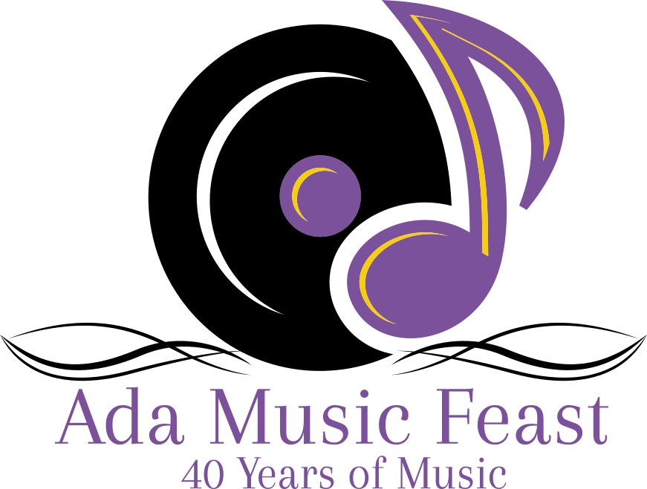

Schedule of Events
November 12, 2022

PERFORMANCE TIME | SCHOOL | GROUP | CLASS
9:30am | Licking Valley | Vocal Impact | B
10:00am | ETC | Rouge | Treble(Univoice)
10:30am | Teays Valley | Glamorous Edition | Treble(Univoice)
11:00am | Alliance | Jetsetters | A
11:30am | Judges Break
12:15pm | Crestview | Knight Vision | C
12:45pm | South Dearborn | Opening Knight | B
1:15pm | Strongsville | Mustang Express | AA
1:45pm | Teays Valley | Prominent Rendition | AA
2:15pm | ETC | All Americans | AA
2:45pm | Ada | Varsity Singers | Exhibition
3:15pm | Piqua | The Company | A
4:00pm | DAYTIME AWARDS | GYMNASIUM

.

Finals
6:00pm | GROUP 1
6:30pm | GROUP 2
7:00pm | GROUP 3
7:30pm | GROUP 4
8:00pm | GROUP 5
8:30pm | GROUP 6
9:15pm | AWARDS | AUDITORIUM

Licking Valley: VOCAL IMPACT
The Licking Valley HS “Vocal Impact” is in its twenty-second year at Licking Valley High School. “Vocal Impact” is currently made up of 13 singer/dancers, 15 “Stingers” combo members and 4 “Crew Bees” members from grades 9 through 12. The group takes pride in performing for their community as well as performing for school concerts and competitions. They annually perform for events to honor their local Veterans and First Responders as well as events that raise awareness and funds for those facing personal and financial battles.
This year’s theme is “Outcry.” Throughout history there have been many seasons of change and uprising. As far as we have come as a world of human beings, we still have further to go. We wish all performers the best this competition season.
Song List:

Open Your Eyes
Soloist: Peyton Gant
Signs
Soloists: Landon Curren & Elsa Shaw
Rise
Soloists: Kiarah Smith, Ashley Sweeney, Ashlynne Holloway, Sydney Ricket
Disconnected
This is War
Soloists: Landon Curren & Abi Scott

ETC Heid's School of Musical Arts: ROUGE

ETC – Heid’s School of Musical Arts “Rouge” is a community based ensemble celebrating its 10th season as a competitive unisex show choir.
Rouge is comprised of 40 ladies from the Akron and surrounding areas. These talented young people practice once a week on Tuesdays for 3 and a half hours from 5:30pm-9:00pm at their studio in Akron. Through Rouge each student is given the opportunity to take part in competitive show choir. This could be due to their school not having a show choir, they don’t have the opportunity to be in their school’s show choir, or they want to be in a competitive show choir. They are able to meet new people, make new friendships, and have fun making great music every week.
“Rouge” is excited to be performing here today and want to wish everyone good luck!
Song List

Noise
Soloist: Lila Wagner-Gleeson
Loud
Soloist: Grace Epling
Beautiful Noise/Louder Than Words
Soloists: Madison Dodds and Holly Stanfield
Microphone
Soloist: Claire Romig

Teays Valley: Glamorous Rendition

Glamorous Edition consists of over 50 of the finest musicians from Teays Valley High School. They are under the direction of Eric Farrell, who is supported by Accompanist Kathy Myers with Choreography by A.J. Blankenship. Welcome to the Wizarding World of Harry Potter! Be dazzled by magical feats unlike any you’ve ever seen! Witness as students from Hogwarts take down the evil Voldemort! All while attending class and trying to figure how to make these darn spells work!!! Sit back and enjoy the magical and musical adventures of the students from Hogwarts. "Expecto Patronum"!!!!*
(NOT TO BE PRINTED - For Emcee ONLY -
*Pronounced - Ex-Peck-Toe Pah-Troh-Num) (If you’re comfortable doing so, yell “Expecto Patronum” and act like you’re casting a spell!! - The Potterheads will LOVE it.)

Back To (Magic) School
ABC (Spells You See)/I Can Do That
Soloist - Jayley Mathews
Hold On Together
Soloists - TBD
Spell
Soloist - Olivia Maher
Breaking Free
Legends
Soloist - Scarlett Christman

Alliance: Jetsetters

Auditioned from a student body of 800, the Alliance High School Jetsetters is a competition show choir that performs and competes all over Ohio, Indiana, and West Virginia. This year the group features 20 singer/dancers, a 13-piece live band, and a 7 member stage crew. In their short competition history, the Jetsetters have already captivated audiences bringing home several division champion titles and numerous caption awards including: people’s choice, best costumes, spirit awards, best show concept, best choreography, and best vocals. The Year’s show is called “Cloud 9” and features music that is guaranteed to lift your spirits as we soar to new heights! The Jetsetters are under the direction of Carrie Chunat with Assistant Director Suzanne Stieglitz, Instrumental Director Billy Sheak and Choreography by Bella Yee.

Song List:

Broken Wings

Come Fly with Me

Gravity/Rocket Man
Soloists: Zhaniyah Wood and Sylvia Johnson

Hold you Down
Soloists: Caden Nicholson and Ke’Andre McLendon

Higher and Higher

CRESTVIEW: KNIGHT VISION

Crestview Knight -Vision is a select group of singers/dancers. Knight-Vision has received numerous grand championships, best vocals, best choreography and best band awards along with best male and female soloists in the small school division at competitions in Ohio and Indiana. Knight Vision is under the direction of Sensei Danille Hancock, and is choreographed by Tara Tober and Jacob Jay Jones. The instrumental director is Sensei Brett Latman. Knight-Vision would like to wish all of the competing show choirs best of luck today. Knight Vision’s theme is “Warriors” and is dedicated to the everyday fight all of us face.

Song List:

Separate Ways

Get Out Alive
Soloist: Brady Petrie

Anything Worth Holding Onto
Soloist: Kimberly Sites

Cruisin’ for a Bruisin’
Soloist: Tayla Myers

Warriors

Fight for Love
Soloists: Kennedy Sites, Isaiah Watts

South Dearborn: Opening Knights

Opening Knight is from Aurora, Indiana and is comprised of 26 singers/dancers, 14 instrumentalists, and 4 crew members. Opening Knight is an award winning Small Mixed Show Choir and has won numerous Division Grand Championships, as well as, being named finalists at several competitions. Opening Knight has also received many caption awards such as Outstanding Vocals, Choreography, Instrumentals, Set Design, and Stage Crew. This year, Opening Knight will compete at Ada, Beavercreek, Franklin Community, Loveland, Ross, Fairfield, and Lebanon. Opening Knight is choreographed by Jason Johnson, Brook Smolder, and Jeff Burton. Opening Knight is assisted by Ryan Price and under instrumental direction of Zach Francis. Opening Knight is directed by Justin Selmeyer. Please enjoy South Dearborn Opening Knight.

Song List:

My Type
Soloist: Kooper Witte
Orange Colored Sky
Soloist: Karleigh Kittle
There's A Place for Us
Duet: Taci Hughes, Dakota Probst
I Love Rock N Roll
Soloist: Abby Terrill
Queen Medley
Soloists: Clovis Hudnall, Macie Teke, Jake Britton

Strongsville: Mustang Express!

The Mustang Express is an award winning competition show choir comprised of 29 talented singer, dancers and actors. The group also includes 22 talented musicians and 6 crew members. The mustang express will perform at various showcases and judged competitions. Last year, they achieved numerous awards at different competitions. They ended the competition season with a finals placement, and best vocals and ballad in Sheridan. They hope to keep that momentum going this year.

Tonight, the Mustang Express plans to put on a face and hide behind a mask for a party that’ll never stop. A mysterious host will put everyone in a trance and organize a dance. To all friends who are here, may the splendor never fade. Get ready everyone, for the Mustang Express Masquerade.

Song List:

Masquerade from "Phantom of the Opera"
Maquerade from Berlin

Dancing with a Stranger
If I Had My Way
Soloist: Jessica Deal
Steppin to the Bad Side
Soloists: Uriah Williams, Jah'leel Westmoreland, Isaac Seimer and Anthony Kennell

Teays Valley: Prominent Rendition

Prominent Rendition consists of more than 40 of the finest musicians from Teays Valley High School. They are under the direction of Eric Farrell, who is supported by Accompanist Kathy Myers with Choreography by A.J. Blankenship. This year’s show entitled “Home from War” asks “What is the cost of war” and “How priceless is home once you’ve been away”. Teays Valley Prominent Rendition would like to dedicate this show to the men and women of our armed forces who have faithfully served our country in ways that most of us cannot imagine. Thank you for your sacrifice and for your service.

Song List:

Payphone/This Is It
I’ll Make a Man Out of You
Soloists - David McAllister, Ashton Christianson
I’ll See You Again
My War
Coming Home Finale
Vocal Soloist - Scarlett Christman
Dance Soloist - Jayley Mathews

ETC Heid's School of Musical Arts: All Americans

ETC – Heid’s School of Musical Arts the “All Americans” is a community based ensemble celebrating its 45th “Sapphire” season. The goal of ETC which stands for Energy, Talent & Commitment, is to provide musical education, performance training and varied performance opportunities to its members.
The group is comprised of 41 members from the Akron and surrounding areas. These talented young people practice once a week on Sundays for 4 hours from 1:30pm-5:30pm at their studio in Akron. ETC gives each student the opportunity to take part in a competitive show choir, something that they often do not have at their schools. They make lifelong friendships and create strong bonds with people they would not have met in their everyday lives. All of this is achieved while having fun and taking part in the fun and crazy world of show choir. This year they are backed up by their exciting instrumental combo named the “Garage Band”.
“The All Americans” are excited to be performing here today and want to wish everyone good luck!

Song List:

Swing Dance Party/Jump Jive and Wail
Soloist: Jackson Bird
The Juggernaut
Soloist: Katarina Stevanovic
Dancing
Soloist: Lila Wagner-Gleeson
Diggy/Move/Like That
Soloist: Claire Romig
Dance Like Nobody’s Watching/More
Soloist: Robert Wainwright

Ada: Varsity Singers

Piqua: The Company

Piqua High School Show Choir “The Company” is in its 49th year of experience. “The Company” has established itself as an active, entertaining, and award-winning ensemble. This year’s group includes 54 singer/dancers, an 18-member combo “Audio Hype”, and an 8-member stage crew. In addition to performing frequently in and around the Piqua area, “The Company” has enjoyed success in competition placing in the top six in numerous contests in Ohio, Indiana, and West Virginia. The group has also received caption awards for vocals, choreography, combo, soloists, show concept, and costumes. Last season, the group was awarded 1st runner-up at Beavercreek and Grove City. They also received Grand Champion honors at Ada, Findlay, and Hurricane. This year “The Company” will compete at the Ada Music Feast, Beavercreek, Findlay, Hurricane, and Ross. “The Company” looks forward to the competition season and wishes everyone here today the best of luck.

Song List:

Problem/Feel My Face:
Female- Kirsten Shaneyfelt Male- Zach Shedd
You Won't Succeed in Show Choir
I'd Rather Be Sailing/Set Those Sails solo TBD
MJ Transition
Love Can Move Mountains male solo- TBD

